BARANGAY TINAGO MANAGEMENT SYSTEM

A Thesis Presented to
The Faculty of the College of Computing and Information Sciences

BOHOL ISLAND STATE UNIVERSITY

Balilihan Campus

Magsija, Balilihan, Bohol

In Partial Fulfillment
of the Requirements for the Degree

Bachelor of Science in Information Technology

Karl Patrick | D. | Loquias
Kimberly | O. | Comeghod
Monaliza | R. | Liparto

November 2024

APPROVAL SHEET

This thesis entitled BARANGAY TINAGO MANAGEMENT SYSTEM, prepared and submitted by Karl Patrick D. Loquias, Kimberly O. Comeghod, and Monaliza R. Liparto, in partial fulfillment of the requirements for the degree of Bachelor of Science in Information Technology has been examined and recommended for acceptance and approval for oral defense.

THE THESIS COMMITTEE

SHELLA C. OLAGUIR, PhD
Dean

ANGELICA P. TEREC, LPT ANGELICA P. TEREC, LPT
Adviser English Critic

THE EXAMINING TRIBUNAL

Approved by the Committee on Oral Examination with a grade of ______.

JEAN F. NEBREA, PhD
Chair

SHELLA C. OLAGUIR, PhD CATHERINE LEAH G. GABO, MEng
Member Member

BENJAMIN N. OMAMALIN, PhD
Member

Accepted and approved as partial fulfillment of the requirement for the degree of Bachelor of Science in Information Technology.

November 12, 2024 SHELLA C. OLAGUIR, PhD
Date of Oral Defense Dean, College of Computing and Information Sciences

ACKNOWLEDGEMENT

The great success of the project was made possible through the efforts, understanding, and cooperation of the researchers with the help of the beloved God, who gives the ability, strength, perseverance, and eagerness to accomplish this work.
The researchers would like to extend their heartfelt gratitude to all those who assisted and contributed directly or indirectly to making this study possible.
To the researchers’ beloved parents, for their undying support and sacrifices, especially in terms of moral, financial, and spiritual support.
To Hon. Rosario P. Arado, the research respondent, for the invaluable support, guidance, and sharing of the insightful idea that led to the development of this research study. Your generosity in contributing both time and knowledge has been a fundamental aspect of the success of this endeavor.
To Ms. Angelica P. Terec, thesis adviser and the English critic, for her immense input and effort rendered for the accomplishment of this study and for the time spent correcting the manuscripts, and always there for the researchers and who always gives comments and suggestions on how to improve the system.
To Engr. Catherine Leah G. Gabo, a valued member of the examining panel, for her thoughtful feedback and suggestions, which greatly enhanced the quality of this research.
To Dr. Benjamin N. Omamalin, subject instructor, for generously sharing his knowledge and serving as a of the member of the examining panel. His insights, encouragement, and dedication were instrumental in overcoming the challenges encountered during this study.
To Dr. Shella C. Olaguir, Dean of the College of Computing and Information Sciences, for her steadfast support as one of the esteemed members of the examining panel of the thesis. Her expertise, guidance, and kindness were invaluable in refining this work.
To Dr. Jean F. Nebrea, Campus Director, for the support and encouragement to pursue and finish the research work.
To all those people who were not mentioned and who have been part of the research. Thank you so much!

THE RESEARCHERS

ABSTRACT
The Barangay Tinago Management System (BTMS) was a comprehensive web-based application designed to automate and streamline the administrative processes of Barangay Tinago. BTMS aimed to enhance the efficiency, transparency, and accountability of barangay operations, providing better services to residents and stakeholders. The system integrated modules for residents’ information management, by leveraging technology, BTMS enabled barangay officials to make informed decisions, improve data management and faster community engagement. In conclusion, the Barangay Tinago Management System (BTMS) served as a transformative tool that not only simplified administrative tasks but also fostered a more connected and responsive community.

TABLE OF CONTENTS
TITLE |  | PAGE
TITLE PAGE | ……….………… | i
APPROVAL SHEET | ……….………… | ii
ABSTRACT | ……….………… | iii
ACKNOWLEDGEMENT | ……….………… | iv
TABLE OF CONTENT | ……….………… | vi
LIST OF TABLES | ……….………… | viii
LIST OF FIGURES | ……….………… | ix
PREVIEWS | ……….………… | x
Chapters

1 THE PROBLEMS AND ITS SCOPE |  | PAGE
INTRODUCTION
Rationale | ……….………… | 1
Literature Background | ……….………… | 2
THE PROBLEM
Statement of the Problem | ……….………… | 9
Scope and Limitations | ……….………… | 10
Significance of the Study | ……….………… | 10
RESEARCH METHODOLOGY
Research Design |  | 11
Research Environment and Participants | ……….………… | 11
Data Gathering | ……….………… | 12
Research Procedure | ……….………… | 12
Flowchart | ……….………… | 16
Gantt Chart | ……….………… | 22
DEFINITION OF TERMS | ……….………… | 23

2 PRESENTATIONS OF THE PRESENT AND PROPOSED SYSTEM
A. THE PRESENT SYSTEM
System Narrative | ……….………… | 24
Context Diagram | ……….………… | 26
Event List and Diagram | ……….………… | 27
Findings/Constraints | ……….………… | 27

B. THE PROPOSED SYSTEM
System Rules | ……………………... | 28
Context Diagram | ……………………... | 32
Event List and Diagram | ……………………... | 33
Process Specifications | ……………………... | 37
Program Hierarchy | ……………………... | 41
Database Design | ……………………... | 43
Tables | ……………………... | 43
Schema | ……………………... | 48
Test Data/Cases | ……………………... | 49
Revision of the System | ……………………... | 53
Technical Requirements | ……………………... | 54
Hardware Requirements | ……………………... | 54
Software Requirements | ……………………... | 55
Peopleware | ……………………... | 56
Cost-Benefit Analysis | ……………………... | 56
Present Operating Cost | ……………………... | 56
Proposed Operating Cost | ……………………... | 57
Interface Design | ……………………... | 59
3 SUMMARY, CONCLUSIONS AND RECOMMENDATIONS
A. Summary | ……………………... | 75
B. Conclusions | ……………………... | 75
C. Recommendations | ……………………... | 76
Proposed Action Plan:
Rationale | ……………………... | 77
Objectives | ……………………... | 77
Schedule of Implementation | ……………………... | 77
Mechanics of Implementation | ……………………... | 77
Benefits | ……………………... | 78
REFERENCE LIST | ……………………... | 79
APPENDICES
A. Letter of Intent | ……………………... | 81
B. Modeling Tools | ……………………... | 82
C. Interview/Guide Questions | ……………………... | 84
D. User’s Guide | ……………………... | 85
E. Source Code | ….………………...... | 100
RESEARCHER’S BIODATA | ……………………... | 110
LIST OF TABLES
TABLES |  | PAGE
- User | .………............... | 43
- Transactions | ………................ | 43
- Residents | …………............. | 44
- password_reset_tokens | ……………......... | 45
- family_member | ……………......... | 45
- Events | ……………......... | 46
- comments | ………………...... | 46
- Budget | ………………….. | 46
- Blotters | ………………….. | 47
- Migrations | ………………….. | 47
- Present System Annual Operating Cost | ………………….. | 51
- Proposed System Annual Operating Cost | ………………….. | 57

LIST OF FIGURES
FIGURES |  | PAGE
1 Theoretical and Conceptual Framework | …………….......... | 3
2 Flowchart Log In | …………….......... | 16
3 Flowchart Barangay Residents Dashboard | …………….......... | 17
4 Flowchart Request Form | …………….......... | 18
5 Flowchart Barangay Official Dashboard | …………….......... | 19
6 Flowchart Residents Management | …………….......... | 20
7 Flowchart Financial Management | …………….......... | 21
8 Gantt Chart | …………….......... | 22
9 Diagram of the Present System | …………….......... | 26
10 Event 1: Requesting Documents | …………….......... | 27
11 Event 2: Giving Announcements | …………….......... | 27
12 Diagram of the Proposed System | …………….......... | 32
13 Event 1: Barangay User Authentication | …………….......... | 33
14 Event 2: Adding of Residents | …………….......... | 33
15 Event 3: Adding Blotter Records | …………….......... | 34
16 Event 4: Viewing and Updating Residents | …………….......... | 34
17 Event 5: Adding Budget Planning | …………….......... | 34
18 Event 6: Adding Events | …………….......... | 34
19 Event 7: Adding Immunization Schedule | …………….......... | 35
20 Event 8: User Management | …………….......... | 35
21 Event 9: Adding of Comments | …………….......... | 35
22 Event 10: Viewing Announcements | …………….......... | 35
23 Event 11: Residents Requesting Paper | …………….......... | 36
24 Event 12: Viewing Transactions | …………….......... | 36
25 Event 13: Residents Log Out | …………….......... | 36
26 Program Hierarchy (Barangay Officials) | …………….......... | 41
27 Program Hierarchy (Barangay Residents) | …………….......... | 42
28 Database Schema | …………….......... | 48

LIST OF PREVIEWS
PREVIEWS |  | PAGE
- Login incorrect username and password | …………….......... | 49
- Residents Information Field | …………….......... | 49
- Blotter Records Field | …………….......... | 50
- Budget Planning Field | …………….......... | 50
- Event Field | …………….......... | 51
- Immunization Field | …………….......... | 52
- Log In Page | …………….......... | 59
- Dashboard (Barangay Residents) | …………….......... | 60
- Residents Form Information | …………….......... | 61
- Blotter Records | …………….......... | 62
- Blotter Form | …………….......... | 62
- Blotter Report | …………….......... | 63
- Residents List View | …………….......... | 64
- Residents Details | …………….......... | 64
- Residents Report | …………….......... | 65
- Budget Planning | …………….......... | 59
- Budget Plan Form | …………….......... | 66
- Transaction Report | …………….......... | 66
- Transaction Printable | …………….......... | 67
- Event Management | …………….......... | 68
- Add Event Form | …………….......... | 68
- Health Worker Management | …………….......... | 69
- Add Immunization | …………….......... | 70
- User Management | .……………......... | 70
- Dashboard (Barangay Officials) | …………….......... | 71
- Comment Section | …………….......... | 72
- Document Request Form | …………….......... | 73
- Transaction | …………….......... | 73
- About Us | …………….......... | 74

Chapter 1
THE PROBLEM AND ITS SCOPE
INTRODUCTION
Rationale
Technology advances rapidly, making communication, productivity, and convenience more accessible. Companies adopt technology to streamline operations, improving employee and client efficiency. Innovations in technology enable companies to complete tasks faster and more effectively, enhancing overall productivity. As technology continues to evolve, it plays a crucial role in shaping the future of work and daily life.
Effective management plays a vital role in utilizing technology to improve workplace efficiency. Managing tasks manually can be hectic and exhausting; however, with technological advancements, businesses adopt digital solutions for handling important documents. In some cases, companies even use Artificial Intelligence (AI) to automate processes and increase productivity.
A Barangay Management System (BMS) is a comprehensive plan and program designed to improve the overall administration and management of a barangay, helping barangay officials efficiently manage and organize records, services, and administrative tasks. It aims to enhance governance by automating manual processes, improving data accuracy, and streamlining communication between officials and residents.
In Barangay Tinago, the manual process slows down efficient service delivery, leading to delays and errors. Barangay management automation transforms the delivery of basic services, promoting efficient governance and citizen engagement by embracing digital solutions. The barangay improves the lives of its residents, fostering a more sustainable and equitable community.
The Barangay Tinago Management System aims to automate and digitalize paper requests, enhancing efficiency in serving the community. It provides an easy-to-use platform for storing, organizing, and processing essential barangay data. By automating common tasks, the system reduces manual work and minimizes reliance on informal information, helping prevent errors in decision-making.
Literature Background
The Barangay Tinago's manual processes significantly hindered efficient service delivery, resulting in delays, errors, and public dissatisfaction. Traditional methods struggled to keep up with the growing demands of the community, leading to mismanagement of resources. By implementing Barangay Management automation, these challenges were effectively addressed. Automation streamlined operations, reduced human errors, and accelerated service delivery.
Participatory Democracy Theory. The enactment of the Local Government Code and the Urban Development and Housing Act made the barangay a strong foundational base for the deepening of democratization and decentralization of local governance int the twenty-first century. (Porio, 2019)
Process Virtualization Theory. Explain the transition of a traditional, physical process into a virtual process (Balci, 2014).
The Local Government Code of 1991 (Republic Act No. 7160). Title II, Chapter 2: “Delves into the powers and functions of barangays, including their responsibility to ensure the delivery of basic services and implement local development plans.”
Section 17 a: “Empowers barangay to “adopt suitable technology” for the efficient management delivery of services.” (Pimentel, 1991)

The 1987 Philippine Constitution, Article X, Section 2: Mandate. “The territorial and political subdivisions shall enjoy local autonomy.” (Bernas, 1996)

- - - - - -<>

TINAGO BARANGAY MANAGEMENT SYSTEM

Characteristics and Features
- Convenient to manage and track data
- Automated Document Processing
- Resident Information Management
- Request Tracking System
- Communication and Announcements
- Efficient Data Retrieval and Reporting
- Mobile and Web Accessibility

A Proposed Technology Package

FIGURE 1: THEORETICAL AND CONCEPTUAL FRAMEWORK
The Barangay Tinago Management System aimed to digitize and automate barangay services, improving data accessibility and efficiency. Manual processing can delay information retrieval, but this system addresses that challenge. Its success would greatly benefit society by enhancing services at the grassroots level. Developed using the Rational Unified Process, it employs object-oriented analysis and design, with plans to incorporate studies on aspect-oriented programming (AOP) and other barangay systems.
This study is supported by the Process Virtualization Theory, which explains the transition of traditional, physical processes into virtual processes (Balci, 2014). In this century, people prefer to use digital methods rather than gathering information and performing task manually. By transitioning from traditional methods to technological solutions, individuals can save time, simplify processes, and increase efficiency. With advancements in technology, various digitals and systems have been developed to cater to people’s needs and references.
Another relevant theory is the Participatory Democracy Theory (Porio, 2019), which emphasizes citizen engagement and involvement in local decision-making processes. The implementation of laws such as the Local Government Code and the Urban Development and Housing Act as empowered barangays to involved their constituents in governance, fostering a sense of collective responsibility and community development. By applying these theories, this study aimed to create a system that enhances engagement for both residents and barangay officials, improving convenience and efficiency in local government.
By following these theories, the study may become more engaging to both residents and barangay officials. Through the adoption of digital tools and the shift from manual procedures, residents stand to benefit from improved convenience and efficiency in information access and task completion. Such improvements have the potential to enhance the engagement and participation among residents, as they perceive an overwhelming sense of empowerment and connection to the decision-making processes within their barangay. This increased involvement can lead to more responsive governance, where community concerns are addressed more swiftly and effectively.
The study Design and Implementation of a Hybrid Barangay Information Management System emphasizes adherence to the Department of the Interior and Local Government Act of 1990. This system facilitates the collection, storage, and maintenance of data related to barangays and their officials, enhancing the precision and efficiency of tasks such as file retrieval and service delivery. It also generates computerized documents, including barangay clearances, certificates of indulgence, and reports, aiming to digitally empower the barangay system by providing authorized users with secure access (Intud, 2021).
According to the study of Barangay Integrated Management System with Mobile Support, the system enhances public services delivery in the barangay offices and health centers through centralized data management, efficient handling of public information, and streamlined inventory display. It reduces in–person interactions by introducing a mobile application for scheduling appointments and lodging complaints. The system manages resident profiles, public information, supplies, complaints, appointments, medical transactions, and report generation efficiency, optimizing service delivery while minimizing face-to-face engagements (Lim, 2022).
The study Technological innovations and Future Prospects for the Residents Information Management System for Local Barangay in Surigao City highlights the benefits of a user-friendly interface, streamlined data retrieval, and centralized data for prompt responses. It emphasizes the importance of a resilient system for dependability and underscores technological advancements as opportunities to empower barangay officials, enhancing engagement and facilitating efficient service provision. Collaboration and forward-thinking are vital for seamless integration and progress in barangay administration (Gallera, 2023).
The study titled "One Barangay: A Mobile and Web Barangay Management System" addresses the challenges of managing barangay data manually, especially with population growth and the limitations of tools like MS Word and Excel. The COVID-19 pandemic further highlighted difficulties in handling community information. The proposed system aimed to enhance productivity and services by providing a systematic and secure approach to data management, offering long-term solutions to ensure efficient community administration (Jamis, 2022)
Furthermore, the study Promoting Digital Empowerment through the Implementation of a Barangay Management System highlights the crucial role of barangays, the smallest administrative units, in shaping communities and implementing government projects. With over 42,000 barangays across the Philippines, they serve as the cornerstone of local governance and are essential in realizing the visions of a stronger and more resilient society. By integrating modern technology, barangays can enhance constituent services through the computerization of documents such as barangay clearances and certificates. This study assessed the benefits of ICT in developing a system to expedite barangay transactions and document provision, ultimately empowering barangays as self-governing political units and fostering autonomy over their resources (Bautista, 2015).
The Local Government Code of 1991 (Republic Act No. 7160): Title II, Chapter 2 states that:
“The powers and functions of barangays include their responsibility to ensure the delivery of basic services and implement local development plans (Pimentel, 1991).”

Section 17a states that:
“Barangays are empowered to adopt suitable technology for the efficient management and delivery of services (Pimentel, 1991).”

This section of the Local Government Code emphasizes the barangay's obligation to ensure the provision of essential services and the implementation of local development initiatives. Additionally, the acknowledgment of technological integration highlights a commitment to modernizing and optimizing operational processes, ultimately enhancing service delivery for the benefit of the community.

Also in the 1987 Philippine Constitution, specifically Article X, Section 2, states:

"The territorial and political subdivisions shall enjoy local autonomy (Bernas, 1996)."

The 1987 Philippine Constitution, in Article X, Section 2, mandates that territorial and political subdivisions, including barangays, shall enjoy local autonomy. This constitutional mandate led to the enactment of the Local Government Code of 1991, which defines the creation, existence, and powers of barangays as active participants in local governance. Through this, barangays are empowered to implement policies, manage resources, and address the needs of their communities effectively. This framework ensures that barangays have the authority to initiate programs and services tailored to their constituents, fostering self-sufficiency and community-based development.
With the digitalization of barangay management systems, this also fulfills and manipulates description on how maximizing transparency in local governance is possible together with efficiency. The system assists barangays in better managing documents, records and services through complete automation of processes, making procedures faster while coping with common administrative weaknesses due to manual recording. It would involve making public services better and more reliable, cementing the trust of urban voters by simplifying processes like getting clearances or certificates. Through these systems, a more organized and responsive local governance structure can be developed eventually.
THE PROBLEM
Statement of the Problem
This study aimed to design and develop a Barangay Tinago Management System that served as a platform for barangay officials to efficiently manage residents, financial records, and workers. Additionally, the system provided residents with digital access to important documents such as clearances and certificates. Specifically, this study sought to address the following questions:
- What is the current process for issuing clearances and certificates in Barangay Tinago?
- How does the current method affect barangay officials and residents?
- What challenges or constraints are encountered with the existing processes?
- How should the proposed system be designed in terms of:
- System Rules;
- Context Diagram;
- Even List;
- Process Specification;
- Program Hierarchy;
- Database Design;
- Data/Test Cases;
- Technical Requirements;
- Cost-Benefit Analysis;
- Interface Design;
- What action plan should be proposed to effectively implement the system?
Scope and Limitations
This study focused on the development of a resident record management system for Barangay Tinago. The system enabled barangay personnel to register residents, manage their information, and generate reports for administrative purposes. It also provided residents with the ability to request documents, such as barangay clearances, and make online payments. Designed as a web-based system, it aimed to streamline administrative tasks and improve overall efficiency within the barangay. However, the system was limited to Barangay Tinago and did not integrate with other barangay or municipal-level systems. Online features, such as document requests and payments, required a stable internet connection to function effectively. Additionally, the system was not optimized for older devices or browsers and was intended for use solely by registered barangay residents and personnel.
Significance of the Study
The realization of this Barangay Tinago Management System is to provide convenience and efficiency to the users. This study was conducted to have a functional contribution to society and give benefits to the following:
Barangay Officials. With digital transactions and automated management systems, barangay officials can efficiently handle resident information, financial transactions, and other administrative tasks.
Barangay Tinago Residents. Residents will have easier access to important documents such as clearances and certificates. Additionally, the integration of e-cash for payments ensures more secure and seamless transactions.
Future Researchers. This will serve as a future reference on the enhancement of the existing Barangay Management System.
RESEARCH METHODOLOGY
Research Design
The researchers utilized a developmental research design, which focused on the systematic development and evaluation of technological tools. This approach was applied to create and refine a barangay management system tailored to the needs of Barangay Tinago. The primary purpose of the study was to design a digital platform to streamline barangay transactions, replacing manual processes with efficient and accessible online solutions. The design process involved gathering user requirements, analyzing the existing system, and applying iterative development techniques to ensure the system’s functionality and usability. By employing this research design, the researchers aimed to address specific gaps in the barangay’s management processes and enhance administrative efficiency.
Research Environment and Participants
This study was conducted in Barangay Tinago, located in Tinago, Dauis, Bohol. As of 2020, the barangay had a total population of 3,325 residents. The participants in the study included the residents of Barangay Tinago and the Barangay officials.
Data Gathering Instruments
Interview and observation were conducted by the researchers to collect the needed data on the software requirements and specifications in terms of functionality.
Research Instruments
The researchers were given permission to conduct a personal interview to the barangay officials and the residents in order to gather more data and information regarding the procedures and processes of the service.
Interview
It is the suitable tool or process for gathering and collecting information from the respondents regarding the processes. Interview was conducted by asking important questions through an interview guide. These techniques allowed the researchers to pinpoint the issue with the current system.
Observation
It is an effective instrument to gather information to the development of the system. It is used by observing the research locale to fully understand how to implement this system in the future. To completely comprehend the functions and identify the system boundaries and integrity controls, an observation in the research site was conducted.
Research Procedure
The researchers followed the System Development Life Cycle (SDLC), which is the Agile model used in project management that describes the stages involved in an information System Development Project from a feasibility study through maintenance of the completed System. This approached allowed for flexibility collaboration and rapid iteration, enabling the researchers to respond quickly to changing requirements and delivered a functional system. Furthermore, the System Development Life Cycle (SDLC) framework ensured that the project was thoroughly planned, executed and evaluated, resulting in a reliable and efficient information system.
Phase I: Requirement Gathering and Analysis
This initial phase focused on collecting and analyzing data to understand the barangay’s existing manual system for recording and retrieving information. Through interviews, direct observations, and the utilization of online resources, the researchers identified current inefficiencies and gaps in knowledge. This phase aimed to define a comprehensive set of requirements for developing an improved management system tailored to the barangay's needs.
Phase II: System Design
In this phase, the researchers developed a conceptual design and selected algorithms to implement the system. A structured architecture was planned, detailing functionalities such as administrator access to citizen profiles, report generation, and management of legally immigrated citizen records. For residents, features like document requests, online payments, and complaint submissions were integrated into the system design. This phase ensured that the proposed system would address the gaps identified in the earlier stage.
Phase III: System Modeling
System modeling involved creating a streamlined representation of the proposed management system. The design emphasized efficient data flow and operations, including generating reports for each Purok, accessing citizen profiles, and enabling online document handling. The models developed in this phase served as a blueprint, ensuring the alignment of the system’s functionalities with the identified requirements. By establishing a clear and comprehensive system model, the researchers were able to identify potential issues, optimized system performance, and created a solid foundation for the system’s development and implementation.
Phase IV: Implementation
During this phase, the researchers focused on coding the program and finalizing its features. A programming language was chosen which is PHP, and the core functionalities, such as residents management, report generation, and online payment systems, were implemented. Simultaneously, the researchers collaborated with barangay officials to ensure that the system met practical requirements and usability standards. Through rigorous testing and feedback, the researchers refined the system interfaced and functionality, resulting in a user-friendly and efficient system that catered to the needs of both residents and barangay officials.
Phase V: Integration and Testing
The integration and testing phase involved combining all system components and performing rigorous testing to ensure proper functionality. Each feature underwent validation to identify and resolve any issues or inefficiencies. This phase was critical to ensuring the system operated seamlessly and was free of errors before deployment.
Phase VI: Deployment
Once testing was completed, the online management system was deployed for use within the barangay. Training sessions were conducted for administrators and residents to familiarize them with the system’s features. Post-deployment monitoring was carried out to assess system performance and gather user feedback, which informed subsequent adjustments.
Phase VII: Maintenance
The final phase focused on maintaining the system for long-term usability. Regular updates were implemented to address bugs, enhance features, and adapt to evolving needs. User support was provided to resolve issues and ensure that the system remained reliable and efficient in its operations over time.

Log In
16
FIGURE 2: FLOWCHART LOG IN
If==Barangay Officials

If==Barangay Officials

N
b

a

Y
Y
N
If==Barangay Residents
If==Barangay Officials
Login Correct?
Input username
Input password
Y
N
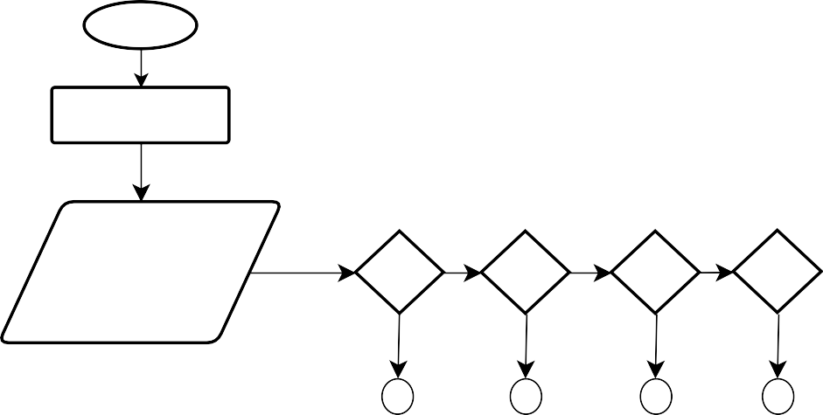
17

a.1 Request Form
a.2 Transaction
a.3 Comments
a.4 Log out

Log-in
If choice==a.1
if choice==a.2
if choice==a.3
If choice==a.4
a.2
a.3
a.4
Post a comment

Comments
Y
Y
Y
Y
End

Log out
a.1

Transaction
View all transaction history
N
N
N
N
a
FIGURE 3: FLOWCHART BARANGAY RESIDENTS DASHBOARD
18
FIGURE 4: FLOWCHART REQUEST FORM
If choice== a.1.1.1
a.1.1.1 Gcash
a.1.2.2 cash
If choice== a.1.1.2
NN
a.1
a.1.1Certificate
a.1.2Clearance
If choice == a.1.1
if choice== a.1.2

Request Form
NN
Y
Y
Y
Y
N
N
Done
a.1
If
choice== a.1.1.1
If
choice== a.1.1.1
Payment
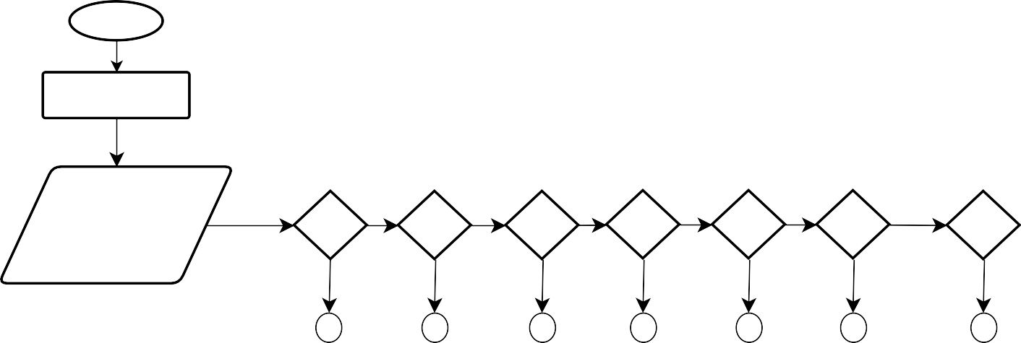
Log-in
Barangay Official
Dashboard
b.1 Residents Management
b.2 Financial Management
b.3 Event Management
b.4 Health Worker Management
b.5 User Management
b.6 About Us
b.7 Log out
b.1
b.2
b.3
b.4
b.5
b.6
b.7
b

If choice==b.4
If choice==b.5
If choice==b.6
If choice==b.7
Archive
About us
User Management
Display all the user
Health Worker Management
Add immunization schedule
Display the Barangay Officials
Log Out
End
If choice==b.1
If choice==b.2
b.2

Event Management
Add event

Y
N
N
Archive
If choice==b.2

19
FIGURE 5: FLOWCHART BARANGAY OFFICIAL DASHBOARD
b.1

Y
Y
Y
Y
N
N
N
N
N
Y
Y

b.1
b.1.1 add residents
b.1.2 residents list
b.1.3 blotters record
if choice==b.1.1
if choice==b.1.2
if choice==b.1.3
add residents
input
residents information
Input Blotters Data
Save

Edit Residents
Information
view details
blotters list
residents list
Residents Management
Save/Update
N
Save/Update
N
N
Y
Y
Y
20
FIGURE 6: FLOWCHART RESIDENTS MANAGEMENT

b.2
if choice==a.2.1
If choice==b.2.1
Input Budget Plan Information
transaction reporting
budget planning
Financial Management
a.2.1 budget planning
b. 2.1transaction reporting
Y
N
Display transactions
Y
N
Generate reports
submit

Y
Y

FIGURE 7: FLOWCHART FINANCIAL MANAGEMENT
18
add event

Event Management
b.3
Delete
add event

Event Management
b.3
Delete
add event

Event Management
b.3
Delete
add event

Event Management
b.3
Delete
add event

Event Management
b.3
Delete
add event

Event Management
b.3
Delete
add event

Event Management
b.3
Delete
add event

Event Management
b.3
Delete
20
p
21
SCHEDULE OF ACTIVITIES

ACTIVITIES | March 2024 |  |  |  | April 2024 |  |  |  |  | May 2024 |  |  |  |  | June 2024 |  |  |  | July 2024 |  |  |  | August 2024 |  |  |  | September 2024 |  |  |  | October 2024 |  |  |  | November 2024
1. Planning

Looking for Topic

2. Analysis

Data Gathering
Prototyping
3. Design

Identify Events
Event Diagram
Database Design
Input Designing
Process Designing
Output Designing
Integrity Controls
Security
Cost Analysis
4. Development

Programs
Management
Manage Account
5. Final Document

Creation and Finalization of Draft
Correction and Adjustments
Final Documentation
22
FIGURE 8. GANTT CHART
DEFINITION OF TERMS
The study had identified the following terms in order to have a common structure of understanding to avoid conflict of ideas and clarify all matters being discussed.
Barangay Management System. Is a digital platform designed to streamline and automate administrative tasks and services within a barangay, the smallest administrative division in the Philippines.
Communication Networks: Systems and channels used to facilitate the exchange of information between individuals or groups. It enhances communication networks between barangays and community constituents, promoting transparency and accountability.
Digital Solutions. Technological tools and systems used to improve processes, access information, and enhance communication. Used to modernize barangay operations, making them more efficient and responsive to community needs.
Tinago. It is a barangay in municipal of Dauis with a total of 3,587 active residents.

Chapter 2
PRESENTATION OF THE PRESENT AND PROPOSED SYSTEM
A. PRESENT SYSTEM
System Narrative
Barangay Tinago is a well-known governmental institution located in Dauis, Bohol. It composed of a total 3,587 residents, who actively participate in community programs and services. The barangay is dedicated to maintaining peace, order, and the well-being of its citizens through various social, health, and infrastructure initiatives.
Manual processing of information storage and retrieval poses significant challenges for many barangay officials. For instance, the secretary must update records annually to reflect any changes in household information. This process involves locating multiple documents to retrieve the necessary details about residents requiring updates. Such tasks are not only time-consuming but also exhausting.
This also includes disseminating essential information to residents, ranging from event announcements to healthcare updates. Relying on manual processes to communicate information can be problematic, as it may be taken for granted by individuals with ill intentions, leading to miscommunication. Verbal communication can alter crucial details, further enhancing the risk of misunderstanding. In addition to that, in terms of financial management, budget planning and transaction reporting also become difficult when using manual methods.
For residents, communication through physical contact is often inconvenient, as not everyone is available during announcements. This can result in some individuals missing important events, ultimately hindering community engagement and participation.
Additionally, obtaining clearances and certificates is inefficient nowadays, as they must visit the barangay hall in person. If they arrive at an inconvenient time, the barangay captain may not be present, further delaying the process. This situation not only wastes residents' time but also discourages them from seeking necessary documents, leading to potential issues with compliance and access to services. Furthermore, the lack of a streamlined process can create frustration among residents, ultimately impacting their trust in local governance.
The Barangay Tinago Management System benefits not only the barangay officials but also the residents, thereby enhancing the positive impact on local governance. This system facilitates various processes, from storing and retrieving data to disseminating crucial announcements. Furthermore, residents will have easy access to important documents, such as clearances and certificates, streamlining their requests and reducing the time and delays associated with these processes. Additionally, residents will receive timely updates on important announcements within the barangay.

Feed Backing

Giving Announcements

Barangay Tinago Manual System

Residents
Barangay Officials

Getting information in a notebook.

Inquiries of important documents

Figure 9: Context Diagram of the Present System

Event List
1. Manual Process of requesting important documents.
2. Manual Process of Giving Announcements
Event Diagram
Residents

Requesting important documents
Barangay Officials

FIGURE 10: EVENT 1. REQUESTING IMPORTANT DOCUMENTS
Residents

Giving Announcements
Barangay Officials

FIGURE 11: EVENT 2. GIVING ANNOUNCEMENTS

Finding and Constraints
From the gathered data, the researchers were able to identify some troubles like being inefficient manual process, potential miscommunication and ineffective access to documents. Thus, the needs of the system are as follows:
1. A centralized digital platform for storing and retrieving documents would streamline access and reduce the time spent on manual processes.
2. An online portal where residents can access necessary documents, such as clearances and certificates, would reduce the need for in-person visits to the barangay hall.
3. A feature for managing and announcing community events would facilitate resident participation and engagement.
The implementation of the Barangay Tinago Management System signifies a modern approach to communication with local residents while enhancing the effectiveness of barangay officials. With the ever-increasing demands for obtaining important documents and announcing crucial information, a dedicated digital platform like the Barangay Tinago Management System can significantly reduce the time and effort involved in these processes. By streamlining operations, the system not only improves accessibility for residents but also empowers officials to serve the community more efficiently.
This system can also serve as a valuable tool for data analysis and decision-making. By collecting and storing information on various aspects of barangay life, such as demographics, permits, and complaints, the system can provide valuable insights to help barangay officials identify trends, allocate resources effectively, and make informed decisions that benefit the community.
B. THE PROPOSED SYSTEM
System Rules
In the facts gathered by the researchers about applications process of the recent system, the Barangay Tinago Management System conceptualized. The researchers were motivated to design and come up with a proposal to create and develop a management system for the barangay officials that can benefit also the barangay residents after dealing with the challenges listed above. At its core, this system offers a comprehensive digital platform designed to store and retrieve data, disseminate announcements, facilitate financial budgeting, and manage transaction reporting. By integrating these functions into a single system, it ensures that barangay operations are more organized, transparent, and efficient. This not only simplifies the workflow for barangay officials but also provides residents with faster access to essential services and information.
1. User Roles and Access
- Barangay Captain: The primary administrator with full access to the system's features, overseeing operations, and making key decisions.
- Authorized Barangay Staff: Staff members granted specific permissions to manage records, process requests, and assist residents as per their assigned roles.
- Barangay Residents: The registered users who can view relevant announcements, access services, and make requests such as certificates and clearances.
2. Resident Management
- Adding and Updating Resident: This allows authorized personnel to register new residents, update existing records, and ensure accurate information on residency status and personal details.
- Blotters Record: A section to record and manage complaints or incidents reported by residents for documentation and potential resolution.
- Resident List: A searchable list of residents, providing authorized users with quick access to resident details for efficient management.
3. Financial Reporting
- Budget Planning: Used to plan and allocate barangay funds for community projects, operational costs, and other financial needs, ensuring transparent budgeting. This budgeting process helps prioritize the need of the community and ensures that funds are utilized efficiently and effectively.
- Transactions: A record of all financial transactions, including expenses and income, supporting tracking and accountability of funds. This record should be regularly audited and made by accessible to authorized barangay officials for eternal review and monitoring.
4. Announcement Management
- Health Services Announcements: Updates and information on health services, such as vaccination schedules and medical assistance programs. These updates can be disseminated through social media, barangay newsletter and public announcement to reach a wider audience.
- Event Announcements: Information about barangay events to promote participation and awareness among residents. This can help faster sense of community and social responsibility among young people.

5. Communication Method
- Comments: A platform for residents to communicate with the barangay officials and leave feedback that enables residents to participate in decision-making processes and hold officials accountable for their action.
6. Request Paper
- Enables residents to request official documents, like certificates of residency or other certifications needed for personal and legal purposes. This streamlined process saves residents time and effort, and helps ensure that they received the necessary documents in a timely and efficient manner.
7. Payment Management
- Payment Method Selection: Provides various options for residents to make payments for services or fees required by the barangay, such as for clearances and certificates.
- Tracking and History: A log of payments made by residents, including dates, amounts, and types, to ensure transparency and help residents monitor their transactions.
8. System Security and Data Privacy
- User Authentication: All users (barangay officials and residents) must log in using secure credentials. Password encryption is applied to ensure data security.

- Announcements
- Request Paper
- History
- Comments
- Residents Management
- Financial Management
- Event Management
- Health Worker Management
- User Management
- Comments
Barangay Tinago Management System
Barangay Residents
FIGURE 12: CONTEXT DIAGRAM OF THE PROPOSE SYSTEM
Barangay Officials
Event List
- Barangay Official/Resident Login and Authentication
- Barangay Official Adding Residents
- Barangay Official Adding Blotter’s Record
- Barangay Official Viewing and Updating Residents Information
- Barangay Official Adding Budget Planning
- Barangay Official Adding Event
- Barangay Official Adding Immunization Schedule
- Barangay Official User Management
- Barangay Official Adding Comments
- Residents Viewing Announcements
- Residents Requesting Paper
- Residents Viewing History
- Barangay Official/Residents Log out
Event Diagram

Process Login
Barangay Official/Residents
Authentication Success

FIGURE 13: EVENT 1: BARANGAY OFFICIAL/RESIDENTS LOGIN AND AUTHENTICATION

Barangay Official
Add Residents
Recording of Residents

FIGURE 14: EVENT 2: BARANGAY OFFICIAL ADDING RESIDENTS
Barangay Official
Add Blotter
Add Blotter’s Record

FIGURE 15: EVENT 3: BARANGAY OFFICIAL ADDING BLOTTER RECORDS

Residents Information
View Details
Residents List
Barangay Official
Update Residents Information
Save Changes

FIGURE 16: EVENT 4: BARANGAY OFFICIAL VIEWING AND UPDATING RESIDENTS’ INFORMATION

Print
Barangay Official
Add Plan
Proceed

Barangay Official
Transaction Reporting
View Transaction Details
FIGURE 14: EVENT 7: BARANGAY OFFICIAL VIEW TRANSACTION DETAILS

FIGURE 17: EVENT 5: BARANGAY OFFICIAL ADDING BUDGET PLANNING

Barangay Official
Event Management
Add Event

FIGURE 18: EVENT 6: BARANGAY OFFICIAL ADDING EVENT
Add Schedule
Immunization Schedule
Health Worker Management
Barangay Official
FIGURE 19: EVENT 7: BARANGAY OFFICIAL ADDING IMMUNIZATION SCHEDULE
Barangay Official
User Management
View All the Users
FIGURE 20: EVENT 8: BARANGAY OFFICIAL USER MANAGEMENT
Add Comments
Comments
Barangay Official
FIGURE 21: EVENT 9: BARANGAY OFFICIALS
ADDING COMMENTS

FIGURE 22: EVENT 10: RESIDENTS VIEWING ANNOUNCEMENTS
Dashboard
Residents
Announcements
FIGURE 25: EVENT 13: BARANGAY OFFICIALS/RESIDENTS
LOG OUT
Barangay Officials/Residents
Processing Logout
Authentication Success
FIGURE 24: EVENT 12: RESIDENTS VIEWING TRANSACTIONS
View Transactions
History
Residents
FIGURE 23: EVENT 11: RESIDENTS REQUESTING PAPER
Request a Paper
Request Paper
Residents
Barangay Official
Comments
Add Comments
Process Specification
1. Login into the Barangay Tinago Management System
Begin
Enter username (username)
Enter password (password)
If admin username and password are correct
Grant Admin Access
Else
Display “Invalid credentials please try again”
End
2. Dashboard
Begin
Display Total Households
Display Total Residents
Display Total Blotters
Display Total Users
Display Map of Barangay Tinago
End
3. Residents Management
If Add Residents
Enter residents’ information
Submit
End
If Blotter record
Add blotter
End
If Residents list
Search request
Filter display
Else
View details, then
Update residents’ information
End
4. Financial Reporting
If Budget Planning
Add planning
Proceed
Download the Excel form
End
Else If Transaction Reporting
View transaction history
End
5. Event Management
Search Request
Filter display
End
Else If
Add event
End
6. Health Worker Management
If Immunization Schedule
Add schedule
Search request
Filter display
End
If Prenatal Schedule
Add schedule
Search request
Filter display
End
7. User management
Search request
Filter display
If Add User
Input user information
Submit
End
Else If Delete User
Successfully deleted
End
Else If Reset Password
Reset successfully
End
8. Comments
Write Comment
Input comment text
Add comment
End
9. About Us
View Barangay Tinago Officials
Display list of officials
End
View Barangay Email
Display barangay email address
End
View Barangay Facebook Page
Display link to barangay Facebook page
End
View Barangay Landline
Display barangay landline number
End
10. Residents Dashboard
Announcements
View Prenatal Announcements
Display prenatal announcement
End
View Immunization Schedule
Display immunization schedule
End
View Event Announcements
Display event announcements
End
11. Request Paper
Select Certificate/Clearance
Add Purok
Write Purpose
If Select Payment Method
If Cash
Submit
End
Else If Gcash
Upload Receipt
Provide Gcash reference Number
Submit
End
End
12. Residents History
View Transaction History
End

Barangay Tinago Management System

Barangay Officials

Comments
User Management
Health Worker Management
Event Management
Financial Management
Residents Management

Delete
Add Immunization Schedule
Add Event
Budget Planning
Add Residents

Reset Password
Archived
Transaction Reporting
Archived
Blotter Record

Add User
Residents List

FIGURE 26: PROGRAM HIERARCHY (Barangay Officials)

41
FIGURE 27: PROGRAM HIERARCHY (Barangay Residents)

Request Documents
Comments
Add Necessary Information
42
Delete
Transaction Process
Transaction
Barangay Residents
Barangay Tinago Management System

Database Design
The following tables are duplicated from the design of the whole system. It states the information that the system used. They state the information that the system uses, ensuring data consistency and proper functionality across all modules.
Table 1. Users: This table contains information about the system users, including barangay official and residents accounts.

Field Name | Data Type | Description
id | int
  A unique identifier for each user, serving as the primary key.
name | varchar
  The full name of the user.
email | varchar
  The email address of the user, used for contact and identification purposes.
contact | varchar
  The user's contact number, which is optional.
username | varchar
  A unique username for the user to log in to the system.
password | varchar
  The user's encrypted password for authentication.
User_ type | varchar
  The type or role of the user in the system (e.g., admin, customer). Optional.
Remember_token | varchar
  A token used for maintaining user sessions, such as "remember me" functionality.

Table 2. Transactions: Stores transaction data related to residents, ensuring accurate record-keeping and easy retrieval for reference and verification.
Field Name | Data Type | Description
id | int | A unique identifier for each transaction, serving as the primary key.
user_id | int | A reference to the user associated with the transaction.
trans_type | varchar | The type of transaction (e.g., payment).
purpose | varchar | The purpose or reason for the transaction.
purok | varchar | The specific location or purok related to the transaction.
mode_payment | varchar | The method used for payment (e.g., cash, online).
file_path | varchar | The file path to any related document or file for the transaction (optional).

Table 3. Residents: Contains detailed information about each resident.

Field Name | Data Type | Description
id | int | A unique identifier for each record, serving as the primary key.
full_name | varchar | The full name of the individual.
sex | varchar | The gender of the individual (e.g., male, female).
date_of_birth | date | The birthdate of the individual.
place_of_birth | varchar | The place where the individual was born.
age | int | The age of the individual.
civil_status | varchar | The civil status of the individual (e.g., single, married).
purok | int | The purok or specific zone associated with the individual.
address | varchar | The address of the individual.
education_level | varchar | The highest educational level attained by the individual.
occupation | varchar | The occupation or job of the individual.
employment_status | varchar | The employment status of the individual (e.g., employed, unemployed).
contact_number | varchar | The contact number of the individual.

Table 4. password_reset_tokens: Manages tokens for password reset functionality.

Field Name | Data Type | Description
email | varchar | The email address associated with the record, used for identification.
token | varchar | A unique token for authentication or verification purposes.
created_at | timestamp | The timestamp indicating when the record was created (optional).
Table 5. family_member: Stores information about family members associated with the head of the household.

Field Name | Data Type | Description
id | bigint | A unique identifier for each record, serving as the primary key.
user_id | bigint | A reference to the user associated with the record.
name | varchar | The name of the individual related to the user.
relationship | varchar | The relationship of the individual to the user (e.g., sibling, parent).
birthdate | date | The birthdate of the individual.
birthplace | varchar | The birthplace of the individual.
creayed_at | timestamp | The timestamp indicating when the record was created.
updated at | timestamp | The timestamp indicating when the record was last updated.

Table 6. Events: Includes scheduling information for events, ensuring proper organization, timely reminders, and efficient event management.
Field Name | Data Type | Description
id | bigint | A unique identifier for each event record, serving as the primary key.
event_type | varchar | The type of the event (e.g., seminar, meeting, concert).
event_venue | varchar | The venue or location where the event will take place.
task_assigned | varchar | The person or group assigned to handle the event's tasks.
date | date | The date of the event.
time | varchar | The time the event is scheduled to occur.

Table 7: comments: A table where users can add and view comments, allowing for interactive discussions and feedback while maintaining a clear record of conversations.

Field Name | Data Type | Description
id | bigint | A unique identifier for each comment record, serving as the primary key.
user_id | bigint | A reference to the user who made the comment.
comment | text | The content or text of the comment.
created_at | timestamp | The timestamp indicating when the comment was created.
updated_at | timestamp | The timestamp indicating when the comment was last updated.

Table 8. Budget: Contains titles and other details related to budget planning.

Field Type | Data type | Description
id | bigint | A unique identifier for each plan record, serving as the primary key.
title_plan | varchar | The title or name of the plan.

created_at | timestamp | The timestamp indicating when the plan was created.
updated_at | timestamp | The timestamp indicating when the plan was last updated (optional).
Table 9. Blotters: Manages complaints and records details about complainants.

Field Name | Data Type | Description
id | bigint | A unique identifier for each blotter record, serving as the primary key.
blotters_name | varchar | The name of the individual or entity involved in the incident.
incident_type | varchar | The type of incident (e.g., theft, vandalism).
location | varchar | The location where the incident occurred.
reported_by | varchar | The name of the person who reported the incident.
responding_officer | varchar | The officer responding to the incident (optional).
status | varchar | The current status of the blotter (e.g., open, closed) (optional).
description | text | A detailed description of the incident.
created_at | timestamp | The timestamp indicating when the blotter was created (optional).
updated_at | timestamp | The timestamp indicating when the blotter was last updated (optional).

Transactions
id | integer
user_id | integer
trans_type | varchar
purpose | varchar
purok | varchar
mode_payment | varchar
Created_at | timestamp

Blotters
Id | Integer
User_id | integer
Blotters_name | varchar
Incident_type | varchar
Location | varchar
Reported_by | varchar
description | text
immunizations
id | Integer
user_id | integre
activity | varchar
venue | varchar
notes | text
Budget
Id | Integer
User_id | Integer
Title_plan | Varchar
Create_at | timestamp

Family_members
Id | integer
User_id | integer
Name | Varchar
Relationship | Varchar
birthdate | Date
birthplace | varchar
users
id | integer
name | varchar
email | varchar
contact | varchar
username | varchar
password | varchar
user_type | varchar
comments
id | integer
user_id | integer
comment | text

residents
id | integer
User_id | integer
Full_name | varchar
sex | varchar
Date_of_birth | date
age | integer
civil_status | varchar
purok | integer
address | varchar
Place_of_birth | varchar
Educational_level | varchar
Occupation | varchar
Employment_status | varchar
Contact_number | integer
events
Id | Integer
User_id | integer
Event_type | varchar
Event_venue | varchar
Task_assigned | varchar

Figure 28: Database Schema

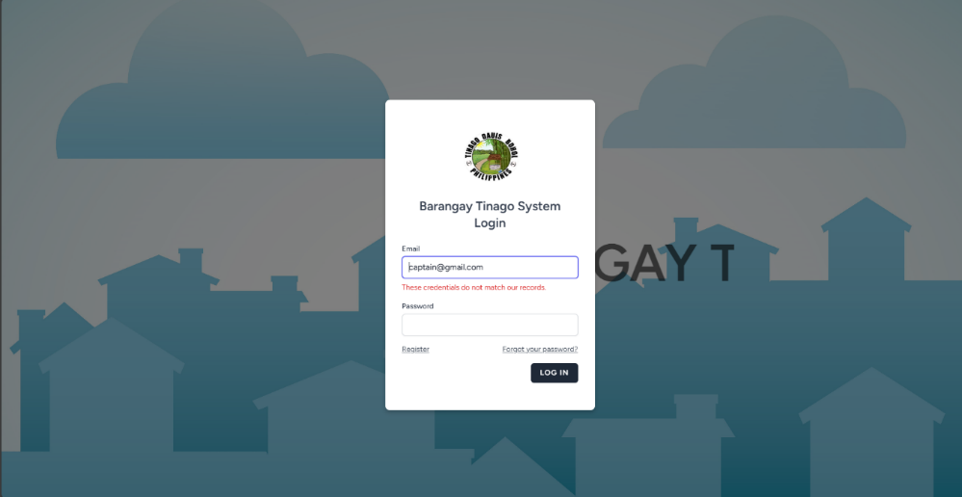
Test Data/Cases

Preview 1: Login incorrect username and password
INPUT: No username and password entered
Wrong username and wrong password
Wrong username and correct password
Correct username and wrong password
PROCESS: System cannot be accessed.
OUTPUT: These credentials do not match our records.
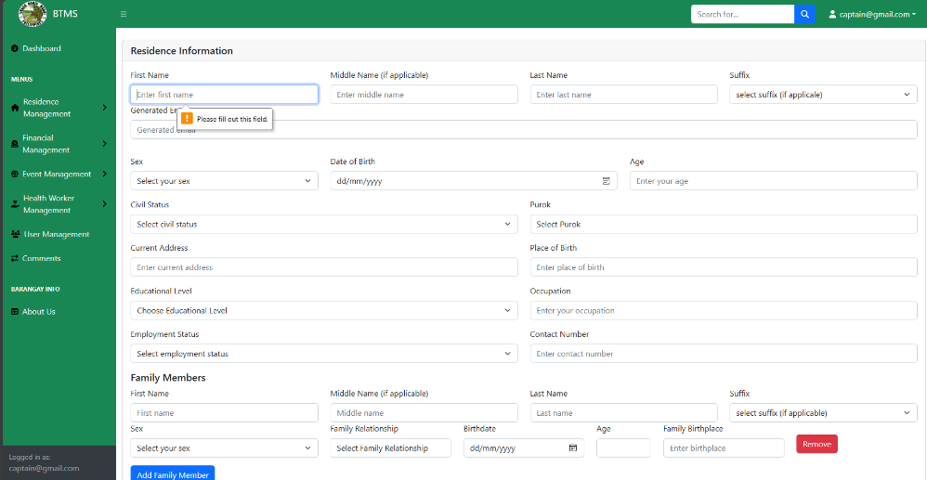
This preview shows the log-in form. A correct username and password are inputted to be able to open an account.

Preview 2: Residents Information Field
INPUT: No information inputted in the fields.
PROCESS: After clicking the submit button.
OUTPUT: Please fill out the fields.
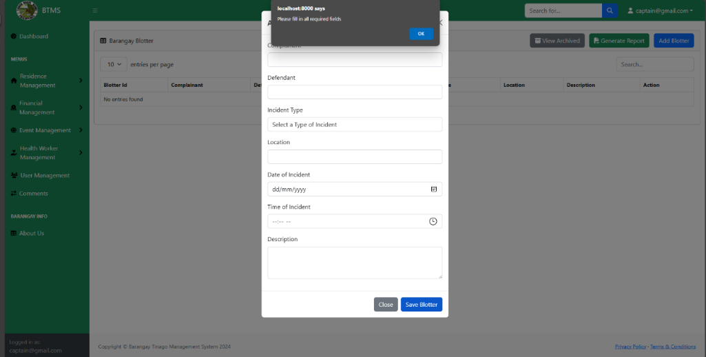
This preview shows the resident information form. All necessary information must be inputted to submit it. Please ensure all fields are accurately filled out to avoid errors. Incomplete or incorrect details may result in processing delays or submission failure.

Preview 3: Blotter Records Field
INPUT: No information inputted in the fields.
PROCESS: After clicking the save blotter button.
OUTPUT: Please fill out all required fields.
This preview shows the blotter records form. All necessary information must be inputted to save the information. Make sure to provide complete and accurate details for proper record-keeping.
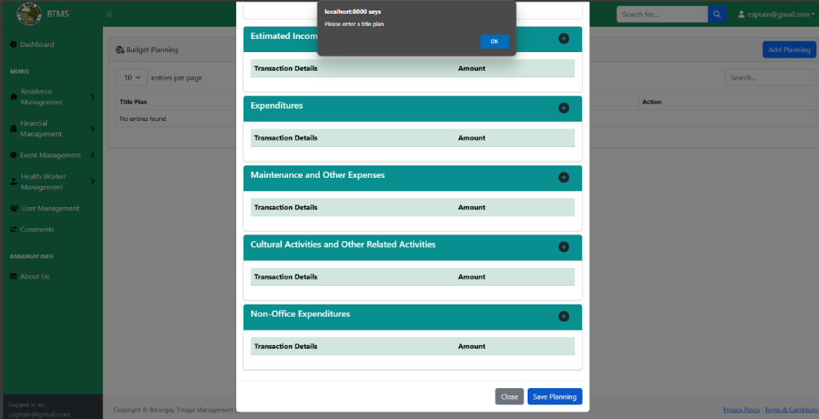

Preview 4: Budget Planning Field
INPUT: No title plan inputted in the field.
PROCESS: After clicking the save planning button.
OUTPUT: Please enter a title plan.
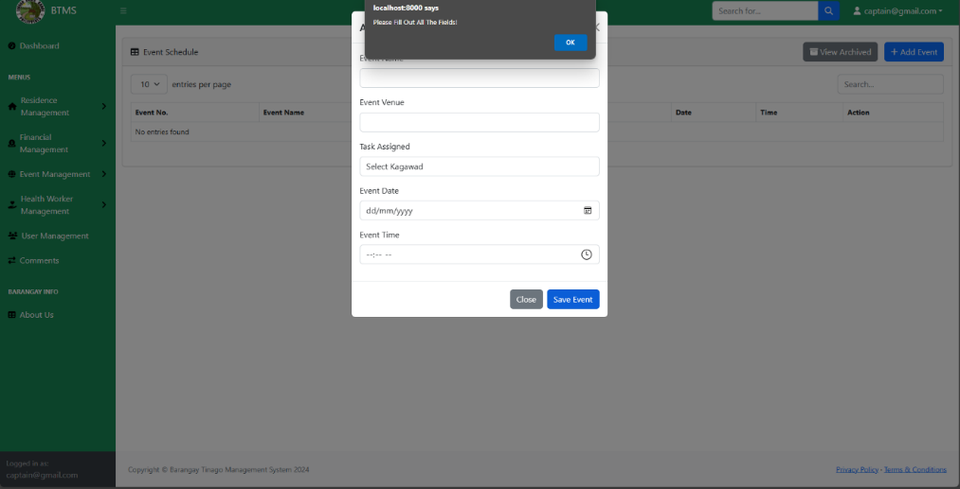
The title plan must be inputted in the field. This ensures that all budget plans are properly recorded and categorized for accuracy. By requiring the title plan, the system can systematically organize financial data, making it easier to retrieve and review when needed.

Preview 5: Event Field

INPUT: No information inputted in the fields.
PROCESS: After clicking the save event button.
OUTPUT: Please fill out the fields.
This preview shows the event information fields. All necessary information must be inputted to save the information. Ensuring complete and accurate data entry helps maintain the reliability of event records. Missing or incorrect details may lead to scheduling conflicts, miscommunication, or incomplete documentation.
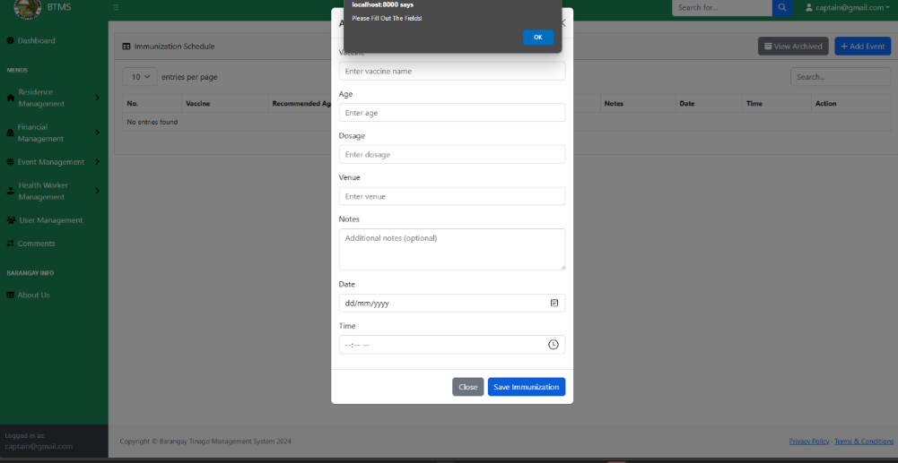

Preview 6: Immunization Field
INPUT: No information inputted in the fields.
PROCESS: After clicking the save immunization button.
OUTPUT: Please fill out the fields.
This preview shows the immunization information fields. All necessary information must be inputted to save the information.

Revision of the System
First Revision
- Include a form with a receipt for each completed transaction.
- Add a feature to filter reports by gender.
- Implement a price management feature.
Second Revision
- Create a payment form.
- Add error trapping to improve functionality.
Third Revision
- Display a notification icon or number for transactions.
- Enable gender-based filtering for household reports.
- Include a list of Purok members, along with their household details.
- For transactions paid via GCash, include a reference number.
Technical Requirements
Hardware, software and peopleware are three essential requirements are needed in the implementation of computerized Barangay Tinago Management System. These three requirements must be present and must work together in newly-developed system. The stability of this system is profitable so that it can last for along span of time.
Hardware Requirements
Hardware contains the entire physical elements that constitute the computer system. Hardware component comprises the Central Processing Unit (CPU), monitor, printer, microprocessor, hard disk drive, optical drive, input and out devices, memory and other peripheral parts of the computer. These components are responsible for fast processing and easy retrieval of data and also supply as storage area which should be compatible reliable and affordable.
Microprocessor
- Minimum requirement: 2GHz
Random Access Memory (RAM)
- Minimum requirement: 8GB
Hard Disk Drive
- Minimum requirement: 512GB
Optical Drive
Mouse
Keyboard
Printer
Software Requirements
Software refers to programmers of the computers. On the hand, these are sets of instructions that are required by the computer for the processing, strong and retrieving of necessary data. Without the software the computer will not be functional. Software can also refer to as the programming language that the researchers will use in the implementation of the automated Barangay Tinago Management System.
Operating System
This software is responsible for controlling the distribution and many different hardware resources such as memory, Central Processing Unit (CPU). disk space and peripheral devices. It provides solid and dependable foundation. The minimal requirement to run the Information System is Windows It also function on higher than Windows such as Windows 10. It is also a user-friendly language.
Application Program: PHP programming Language
The researchers selected PHP as the programming language for designing and developing the management system. PHP provides a wide array of tools and features that enhance the functionality of the system, particularly in creating an intuitive Graphical User Interface (GUI) and handling data efficiently. Its versatility allows the development of programs that align with specific system objectives. Furthermore, PHP enables the creation of database files that store and organize essential categories of data. As a user-friendly language, PHP simplifies development with easily understandable tools and commands, making it an ideal choice for building effective management systems.
Database: MySQL
All the information is stored in this database that is needed in the Implementation of the system. It is a systematically arranged collection of computer data, structured so that it can be automatically manipulated. It can handle and manage a large volume of information. It has the capacity to store and retrieve database information that is efficient and effective.
Peopleware
Peopleware refers to the users of the computer. The system users in the proposed automated Barangay Tinago Management System are the barangay officials and the barangay residents.
Cost-Benefit Analysis
The cost-benefit analysis is the analysis to compare the cost and benefit of the present system Barangay Tinago Management System whether the investment in the development of a new system will be more beneficial than costly.

Table 11. Present System Annual Operating Coast
Total Present Annual Office Supply Cost = ₱32,570.00

ITEM | QTY | UNIT | PRICE | AMOUNT
Black Ink | 5 | Pieces | 580.00 | 2,000.00
Paper | 5 | Ream | 200.00 | 200.00
Printer | 1 | Piece | 4,000.00 | 4,000.00
Computer | 1 | Piece | 25,000.00 | 25,000.00
Pen | 1 | Box | 200.00 | 200.00
Valiant Record Book | 3 | Pieces | 90.00 | 270.00
Total Present Annual Office Supply Cost = ₱31,670.00
00
Table 12. Proposed System Annual Operating Coast
Total Present Annual Office Supply Cost = ₱31,400.00
00
ITEM | QTY | UNIT | PRICE | AMOUNT
Black Ink | 5 | Pieces | 580.00 | 2,000.00
Paper | 5 | Ream | 200.00 | 200.00
Printer | 1 | Piece | 4,000.00 | 4,000.00
Computer | 1 | Piece | 25,000.00 | 25,000.00
Pen | 1 | Box | 200.00 | P200.00

Benefits
The proposed Barangay Tinago Management System introduces a transformative approach to managing barangay operations, addressing existing inefficiencies while providing long-term benefits. One of the primary challenges in traditional barangay management is the reliance on manual processes for data management, communication, and service delivery. This system replaces these time-consuming tasks with a centralized digital database, ensuring accurate and real-time access to information. By streamlining workflows and automating routine tasks, the system reduces delays in services such as document issuance, financial reporting, and resident registration.
Tangible Benefits
The Barangay Tinago Management System saves time, cuts costs, and boosts efficiency by automating resident management, financial reporting, and communication. It minimizes errors, ensures accurate records, and streamlines workflows. By reducing paper use and manual tasks, it lowers expenses while enhancing financial oversight, budget monitoring, and governance transparency. Its user-friendly interface allows barangay officials to access and manage data effortlessly, ensuring smoother operations.
Intangible Benefits
The intangible benefits of the Barangay Tinago Management System extend to all stakeholders, fostering better experiences and stronger trust. For barangay officials, the system supports real-time decision-making, enhances transparency, and simplifies the management of resident information, financial transactions, and announcements. Residents benefit from the convenience of tracking requests, payments, and faster communication with officials for issue resolution. The system promotes sustainable practices by reducing paper use, builds trust through transparency and reliability, and elevates the barangay’s reputation as a modern and resident-focused community.
Interface Design
Screen Layout is one of the system’s attributes and it should be designed in such a way that browsers can navigate the system quickly and easily, providing a clear recognition of the tasks users need to perform. A well-structured layout enhances user experience, reducing errors and improving efficiency.
Object ID: Log In Page
Object Description: The Landing Form
A. GENERAL DESCRIPTION
This page displays the log in page of the website.
B. SCREEN LAYOUT
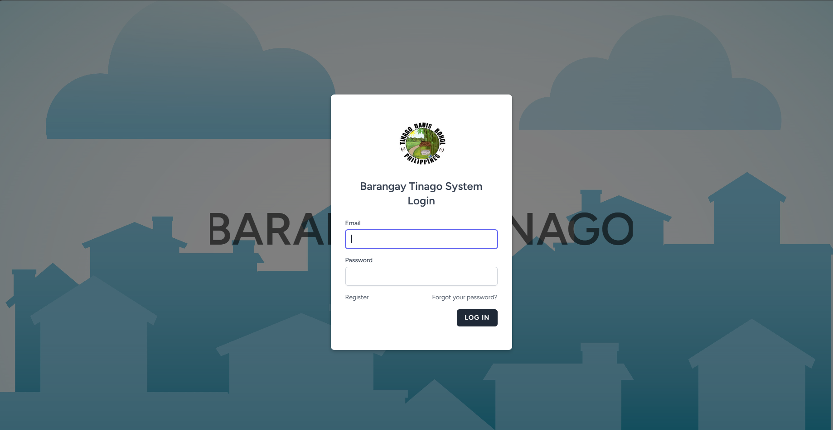
Preview 7: Log In Page

BARANGAY OFFICIALS
Object ID: Dashboard Barangay Officials
Object Description: Dashboard Menu of Barangay Officials
A. GENERAL DESCRIPTION
This page displays the dashboard page of the website in Barangay Officials side, providing an overview of important data, recent activities, and quick access to key functionalities.
B. SCREEN LAYOUT
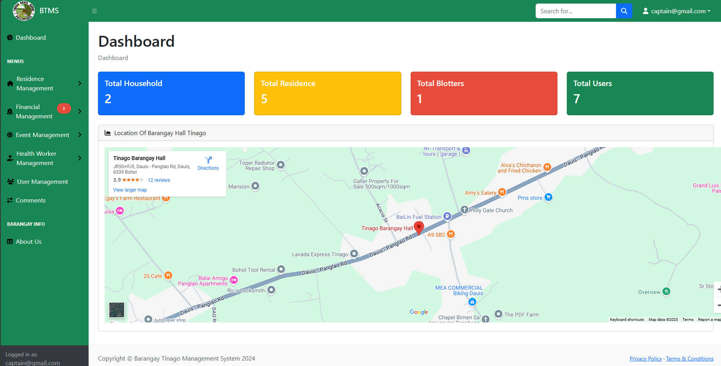
Preview 8: Dashboard (Barangay Officials)
Object ID: addresidents
Object Description: Adding Residents Information
A. GENERAL DESCRIPTION
This page displays the form for adding a barangay resident, requiring essential details to ensure accurate record-keeping and proper documentation.
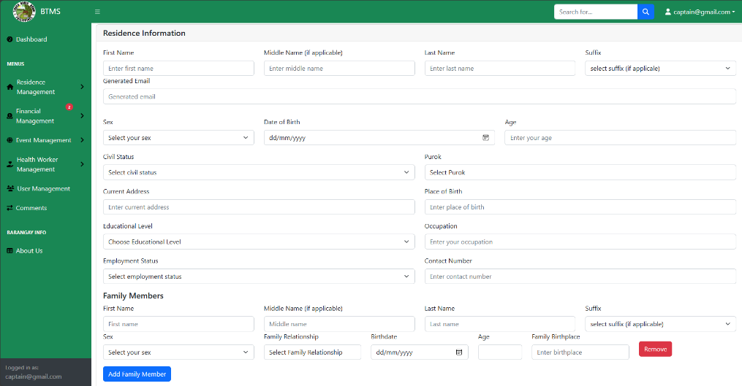
B. SCREEN LAYOUT

Preview 9: Residents Form Information
Object ID: Blotters
Object Description: View List of Blotter Records
A. GENERAL DESCRIPTION
This page lists all blotter records in an organized view for easy tracking and management. Users can search, filter, and sort records efficiently.
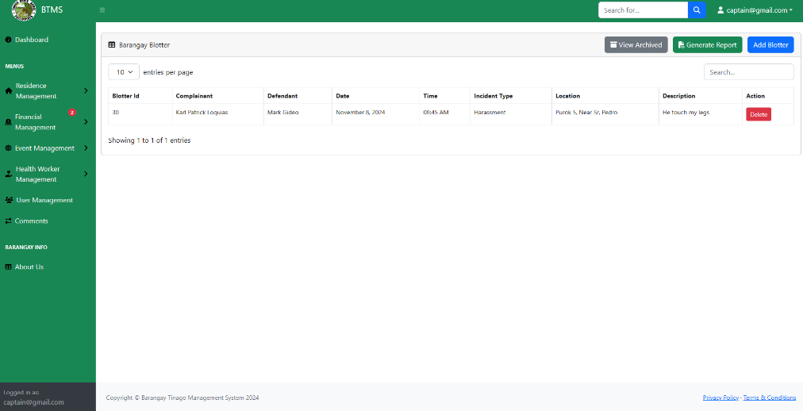
B. SCREEN LAYOUT
Preview 10: Blotter Records
Object ID: Blotter Form
Object Description: Adding Blotter Records
A. GENERAL DESCRIPTION
This page displays a form for adding blotter entries, allowing users to input case details efficiently. It ensures accurate record-keeping by capturing essential information such as complainant, respondent, incident date, and case description.
B. SCREEN LAYOUT
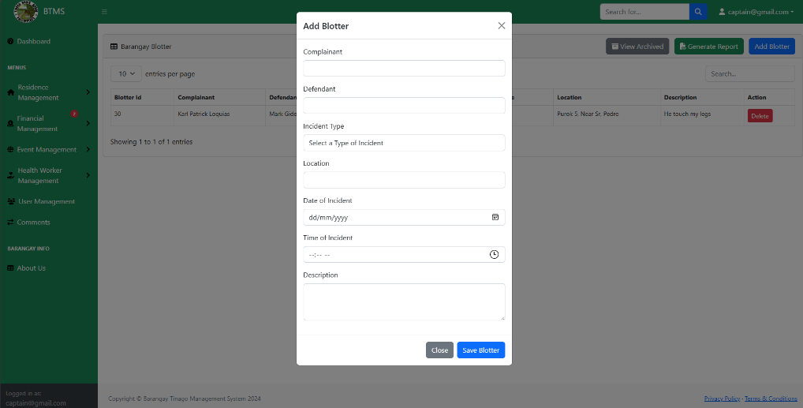
Preview 11: Blotter Form
Object ID: Blotter Report
Object Description: Blotter Report Generation
A. GENERAL DESCRIPTION
This page displays the overall report of the blotter entries, providing a comprehensive record of incidents for tracking and reference purposes.
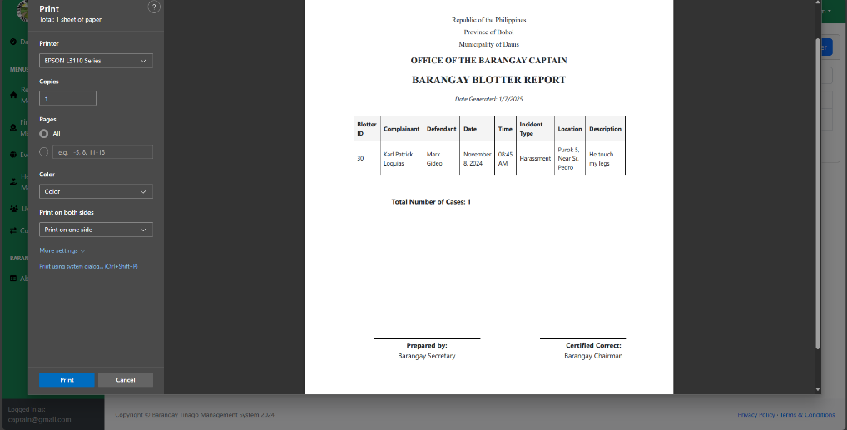
B. SCREEN LAYOUT

Preview 12: Blotter Report
Object ID: Residents View
Object Description: View of all Residents
A. GENERAL DESCRIPTION
This page displays all the residents added, providing an organized list for easy reference.
B. SCREEN LAYOUT
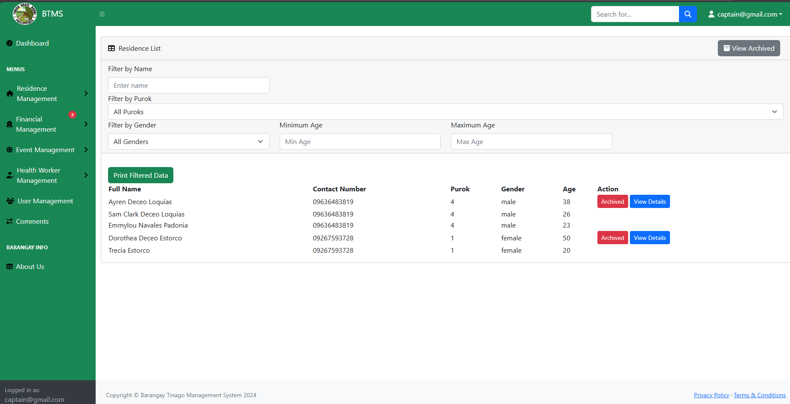
Preview 13: Residents List View
Object ID: Residents Details
Object Description: Showing the Residents Details
A. GENERAL DESCRIPTION
This page displays all the residents’ details, allowing users to view, search, and manage records efficiently. It ensures accurate tracking and easy access to resident information when needed.
B. SCREEN LAYOUT
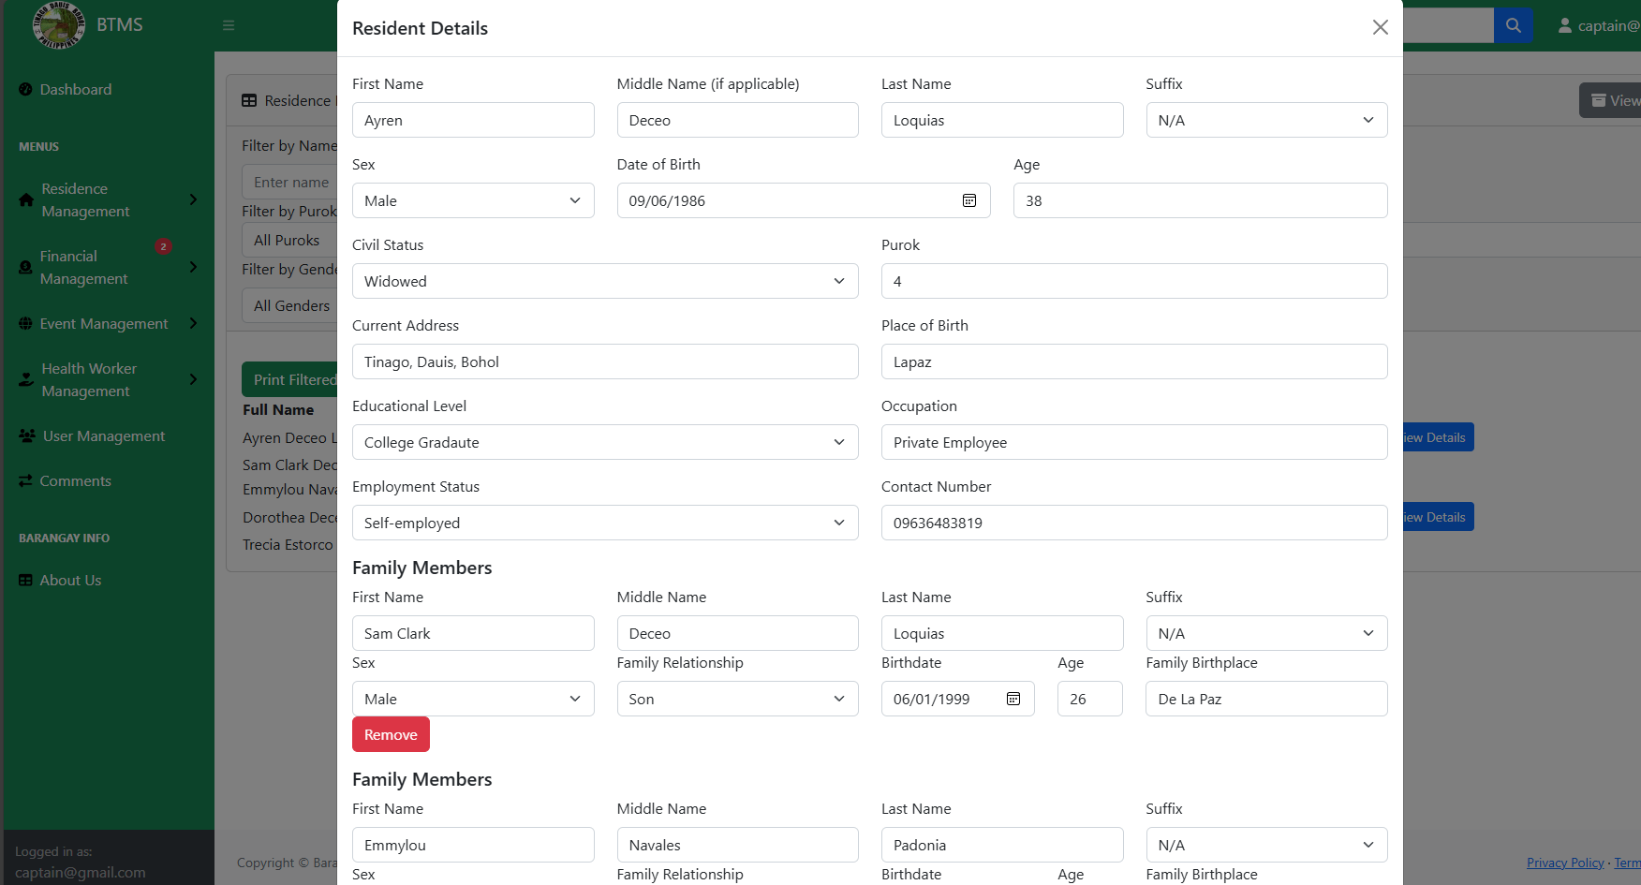
Preview 14: Residents Details
Object ID: Residents Report
Object Description: Residents Report Generation
A. GENERAL DESCRIPTION
This page displays a report of all the residents added, offering a detailed overview for monitoring and record-keeping purposes.

B. SCREEN LAYOUT
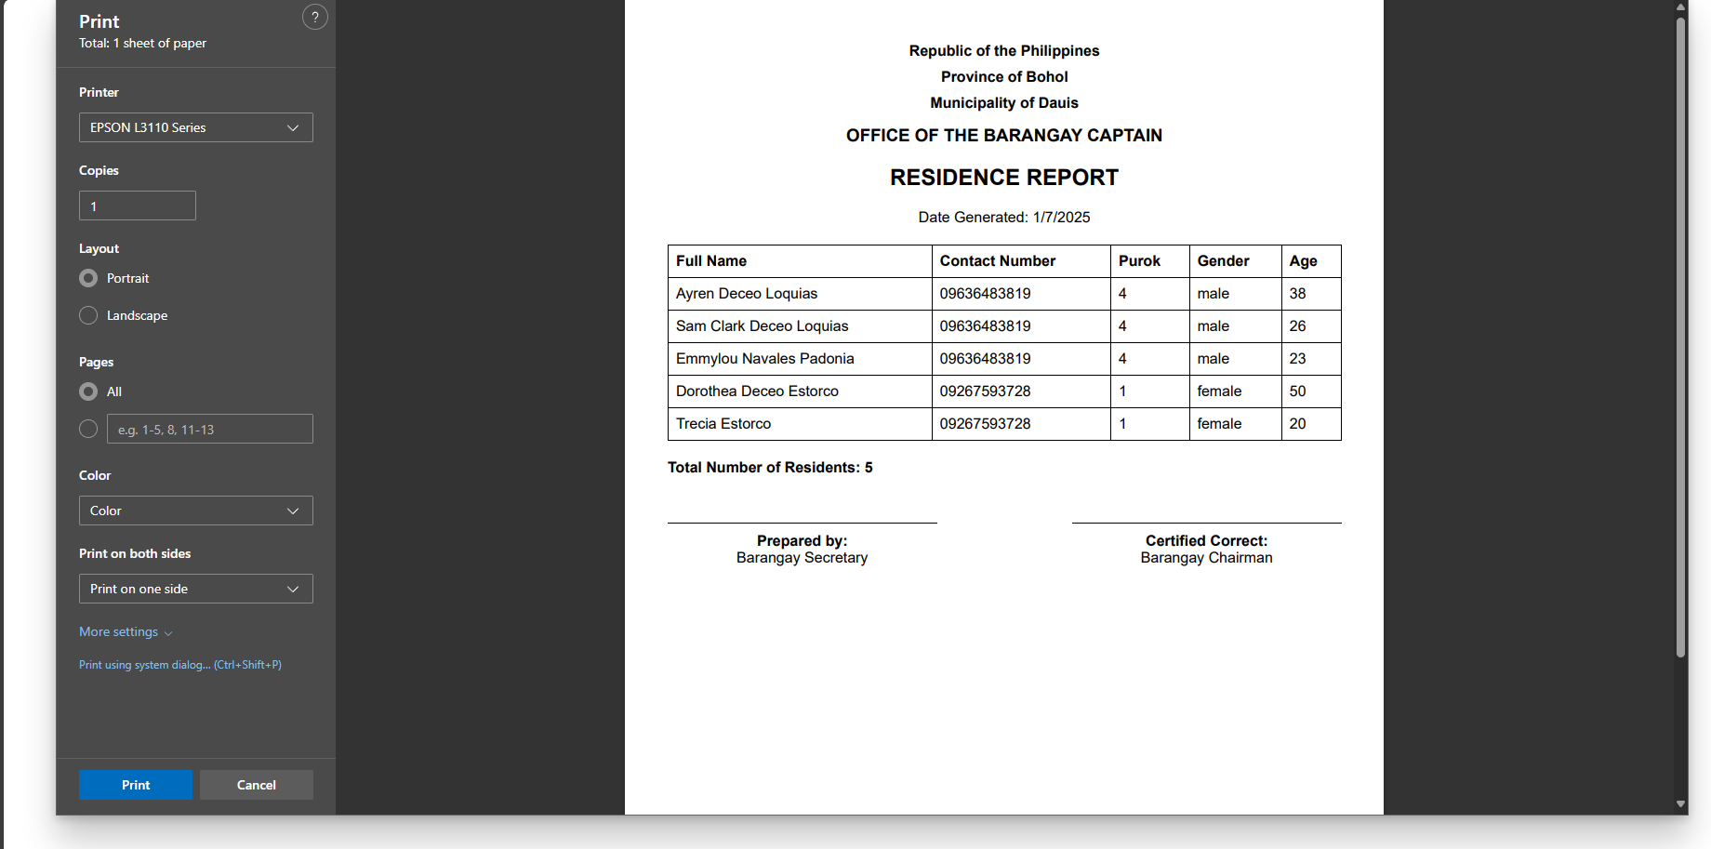
Preview 15: Residents Report
Object ID: Budget Plan
Object Description: View List of all the budget Plan
A. GENERAL DESCRIPTION
This page displays all of the planned budget, allowing users to view, track, and manage financial allocations efficiently.
B. SCREEN LAYOUT
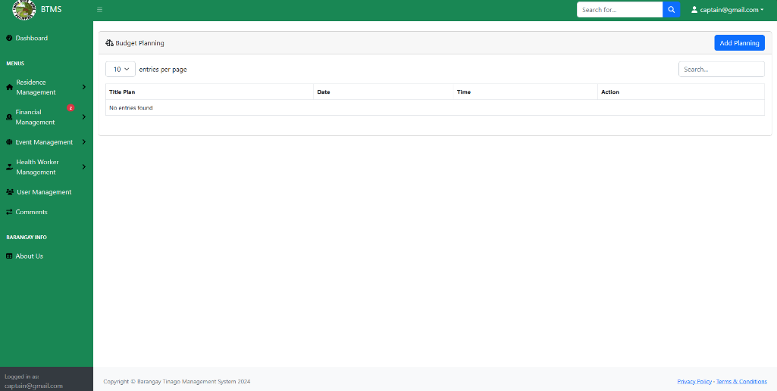
Preview 16: Budget Planning
Object ID: Budget Form
Object Description: Adding Budget Plan
A. GENERAL DESCRIPTION
This page displays the budget plan form, allowing users to input, update, and manage financial allocations easily. It includes fields for estimated income, expenses, and funding sources, ensuring accurate financial planning.

B. SCREEN LAYOUT
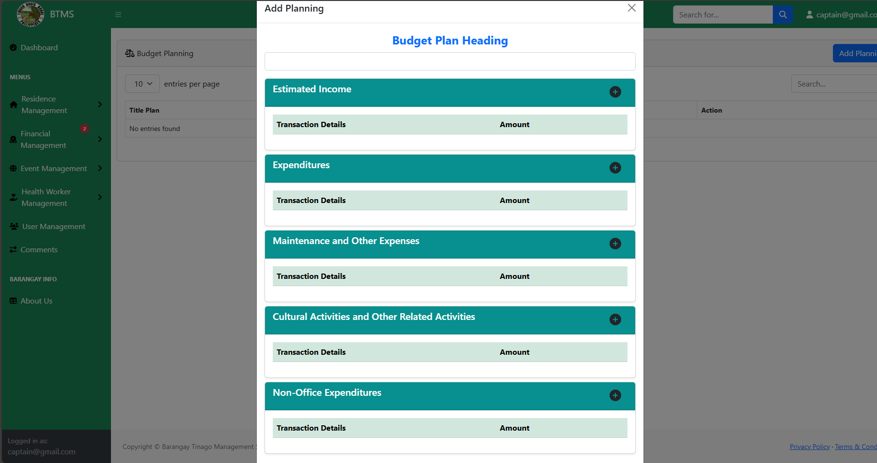
Preview 17: Budget Plan Form
Object ID: Transaction Report
Object Description: View of Transaction
A. GENERAL DESCRIPTION
This page displays all transactions received by barangay officials.

B. SCREEN LAYOUT
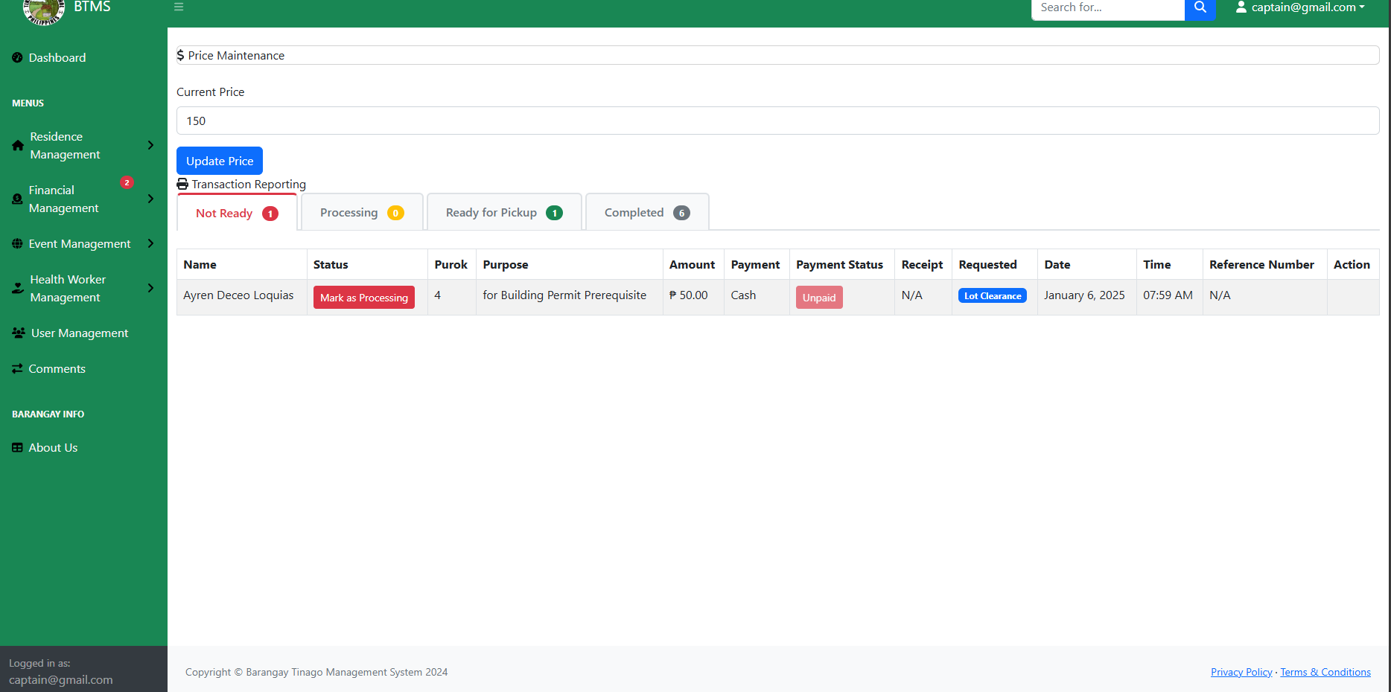
Preview 18: Transaction Report
Object ID: Transaction Printable
Object Description: Transaction Report Generation
A. GENERAL DESCRIPTION
This page displays a report of all completed resident transactions, providing a comprehensive record for tracking and reference.
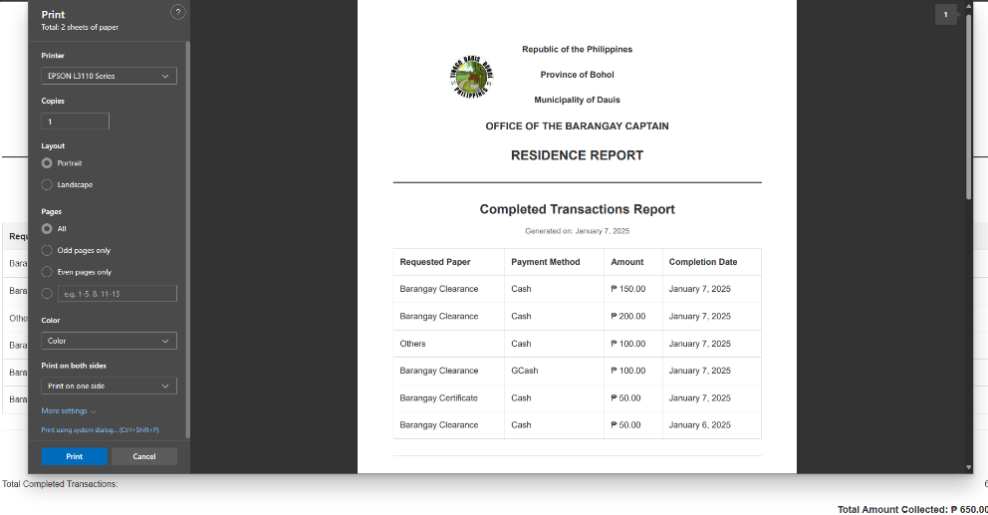
B. SCREEN LAYOUT

Preview 19: Transaction Report
Object ID: Event
Object Description: View List of Events
A. GENERAL DESCRIPTION
This page displays all of the events in the barangay, providing an organized list for easy tracking and management. Users can view event details such as date, time, location, and description, ensuring proper coordination and participation.
B. SCREEN LAYOUT
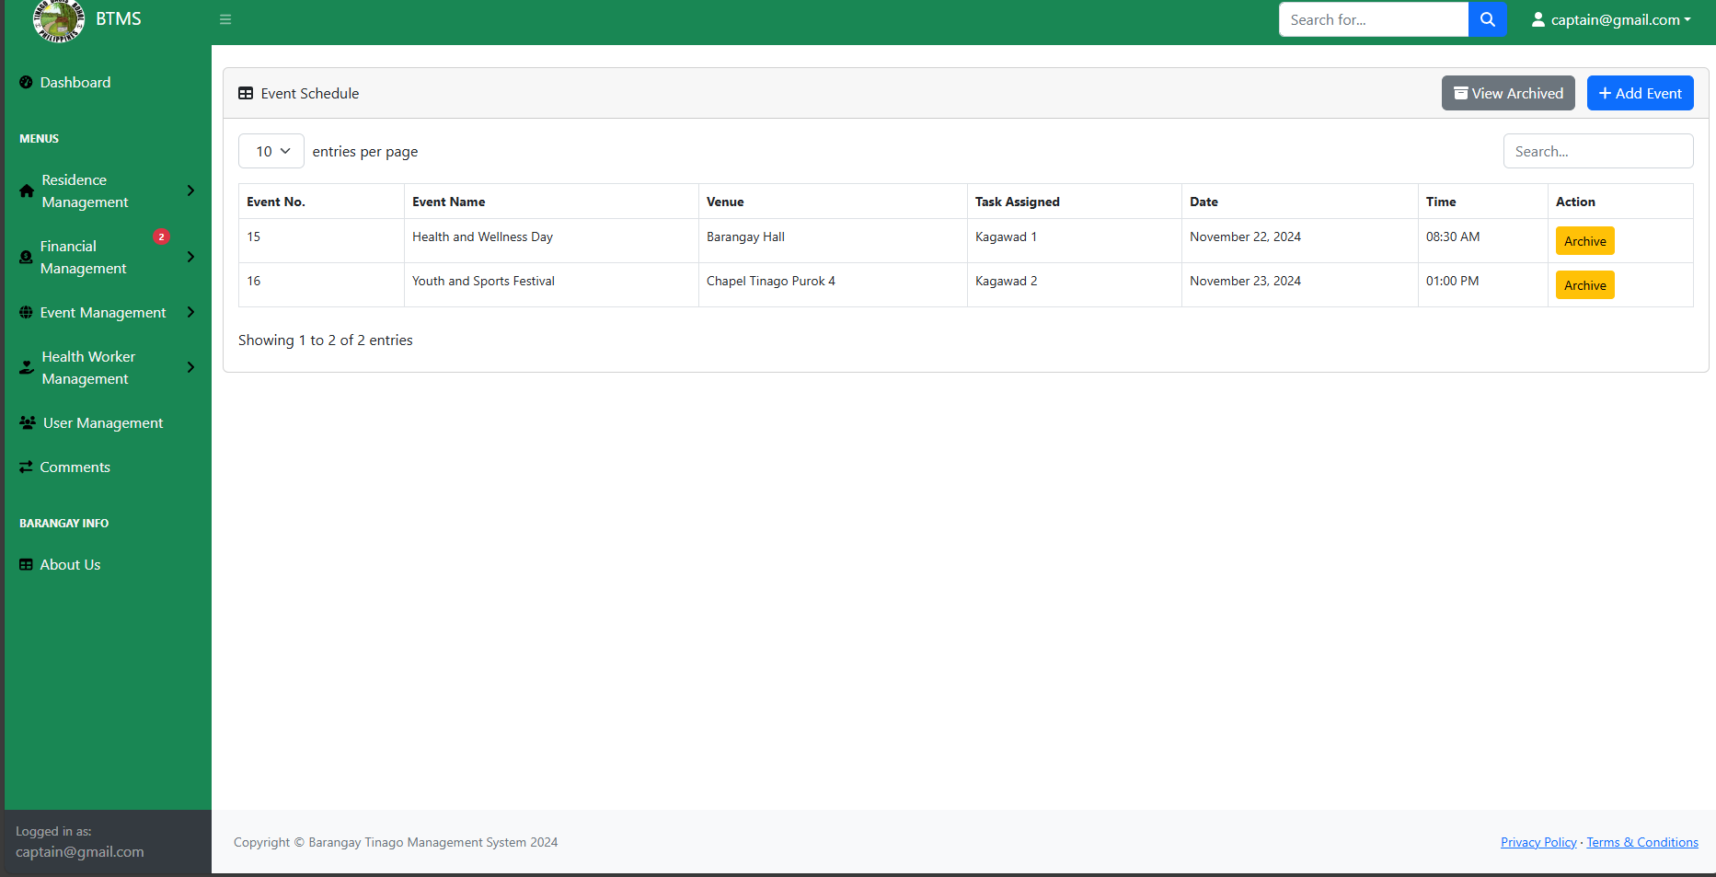
Preview 20: Event Management
Object ID: Add Event
Object Description: Adding Events
A. GENERAL DESCRIPTION
This page displays the event form to add events, allowing users to input essential details such as event name, date, time, location, and description. It ensures proper scheduling and organization for smooth event management.

B. SCREEN LAYOUT
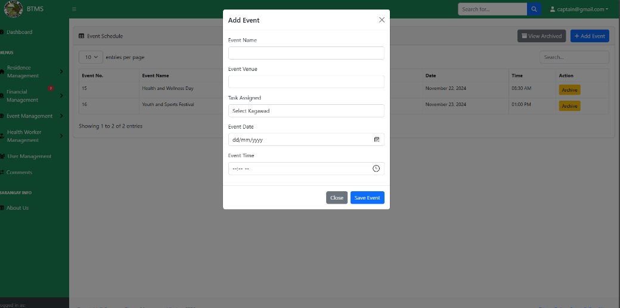
Preview 21: Add Event Form
Object ID: Immunization
Object Description: View List of Immunization schedule
A. GENERAL DESCRIPTION
This page displays all of the events in the barangay, providing an organized list for easy tracking and management. Users can view important details such as event name, date, time, location, and description.
B. SCREEN LAYOUT
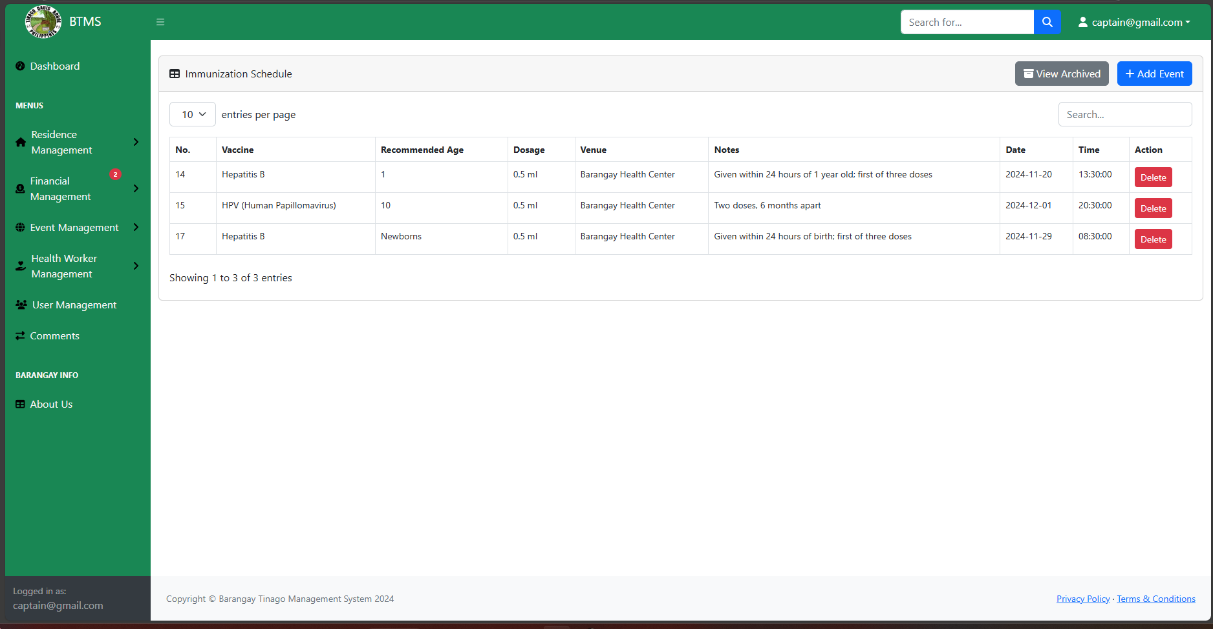
Preview 22: Health Worker Management
Object ID: Immunization Form
Object Description: Adding Immunization Schedule
A. GENERAL DESCRIPTION
This page displays the immunization form, allowing users to input and update vaccination records efficiently. It includes fields for resident details, vaccine type, dosage, date of administration, and healthcare provider, ensuring accurate record-keeping.
B. SCREEN LAYOUT
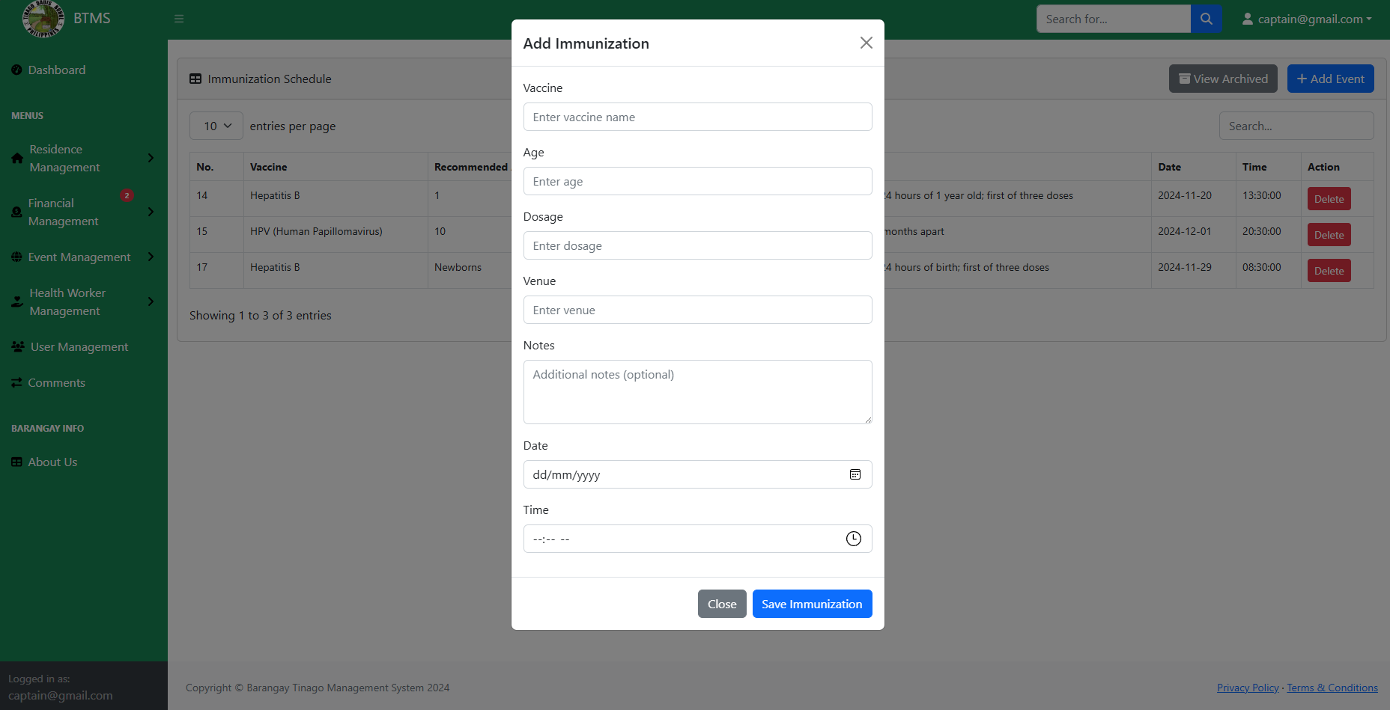
Preview 23: Add Immunization
Object ID: Dashboard Barangay Residents
Object Description: Dashboard Menu of Barangay Residents
A. GENERAL DESCRIPTION
This page displays the dashboard page of the website in Barangay Residents, providing an overview of important announcements, services, and community updates for easy access and engagement.
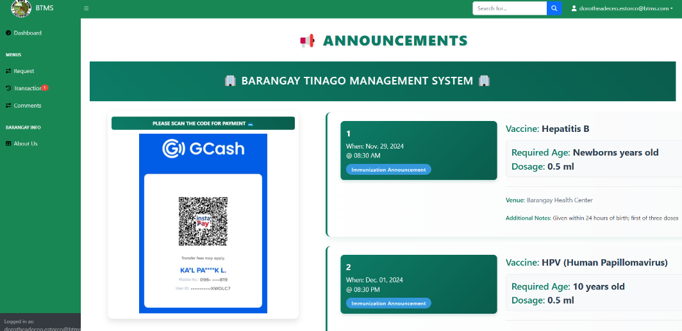
B. SCREEN LAYOUT
Preview 24: Dashboard (Barangay Resident)
Object ID: Users
Object Description: View List of Active Users
A. GENERAL DESCRIPTION
This page displays all active users, allowing barangay officials to manage accounts efficiently. The page also includes search and filter options for quick user management and monitoring.
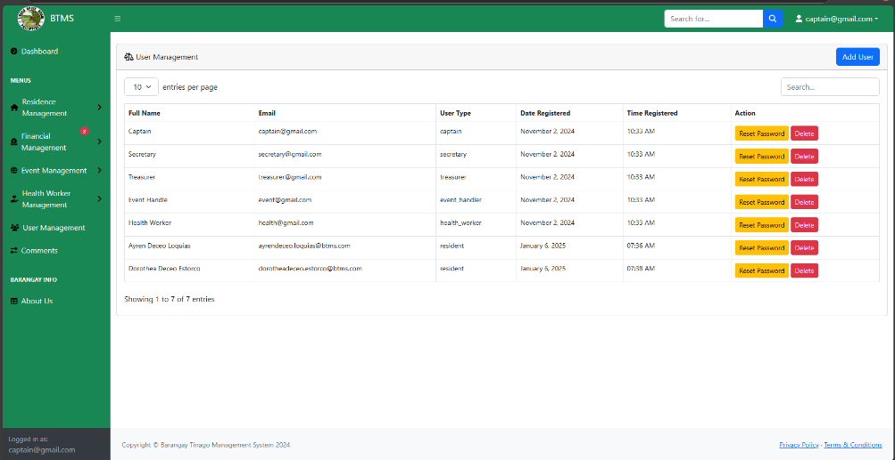
B. SCREEN LAYOUT

Preview 25: User Management
Object ID: Add Comment
Object Description: Adding comments and feedbacks
A. GENERAL DESCRIPTION
This page displays a field where users can leave comments and interact with each other, fostering engagement and communication. Users can share feedback, ask questions, and participate in discussions in a structured and organized manner.
B. SCREEN LAYOUT
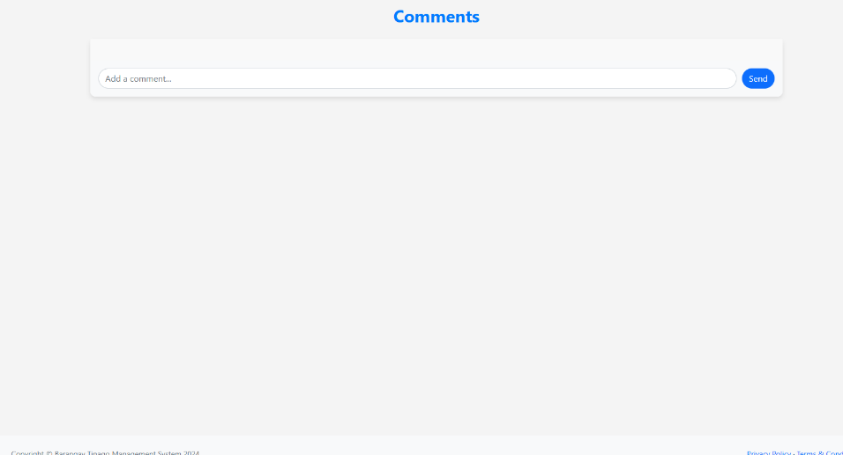
Preview 26: Comment Section

Object ID: Document Request Form
Object Description: Residents Requesting Document
A. GENERAL DESCRIPTION
This page displays a document request form that you can submit, allowing residents to request official barangay documents quickly and efficiently. Ensure all required fields are filled out to process the request without delays.
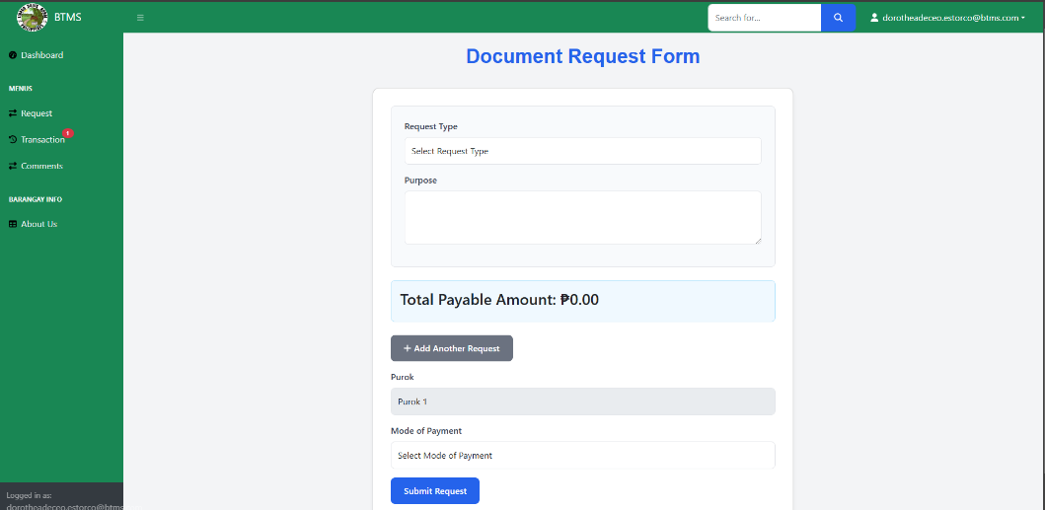
B. SCREEN LAYOUT

Preview 27: Document Request Form
Object ID: Transaction History
Object Description: Viewing of Transaction History
A. GENERAL DESCRIPTION
This page displays all transactions submitted by barangay residents, providing a detailed record of requests, payments, and other official dealings. It allows for efficient tracking, monitoring, and management of resident transactions.
B. SCREEN LAYOUT
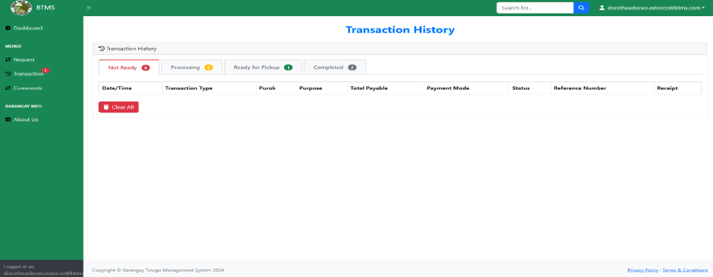
Preview 28: Transaction
Object ID: About Us
Object Description: Viewing of all Barangay Officials
A. GENERAL DESCRIPTION
This page displays all the current Barangay Officials, providing their names, positions, and contact details for easy reference. It helps residents identify and reach out to the appropriate officials for assistance and community concerns.
B. SCREEN LAYOUT
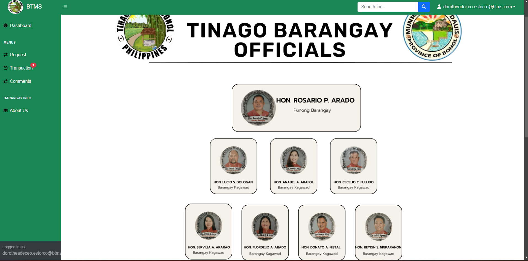
Preview 29: About Us

Chapter 3
SUMMARY, CONCLUSION AND RECOMMENDATIONS
A. Summary
This study aimed to develop a system that will provide an easy way in storing, managing, and processing essential data required by barangays at large. By implementing Barangay Tinago Management System the barangay officials and the residents will have more convenient and hassle- free management more organized in its preparations and processes. Base on observations at Barangay Tinago, the system of Barangay Tinago Management System is an effective way of monitoring and more reliable and accurate rather than manual process.
B. Conclusion
Based on the study, the researchers found that the Barangay Tinago Management System empowers barangay officials by streamlining the issuance of clearances and certificates through automation. This reduces delays, ensures accurate record-keeping, and enhances overall efficiency. Barangay officials experience improved management of transactions and documents, while residents benefit from faster and more accessible services. Additionally, the system addresses the challenges of manual barangay management by minimizing errors, enhancing data security, and promoting transparency and accountability in governance.

C. Recommendations
Based on the study, the following recommendation are:
- Barangay Tinago Management System should be implemented to make the barangay officials more connected.
- Establish a structured system for maintaining and organizing records of barangay residents for easy access and retrieval.
- Must adapt computerized system which provides accuracy in the procedure of monitoring the records.

ACTION PLAN
BARANGAY TINAGO MANAGEMENT SYSTEM
Rationale
The Barangay Tinago Management System different means of record-keeping are used in data information. Some workplace uses hand-written records, others have to moved computer-based system and many use a combination of both Barangay Tinago Management System is using manual system in terms of implementing documents like Barangay Indigence,
Objectives
- To change from the manual process of records and monitoring the residents of Barangay Tinago into a computerized system.
- To improve the efficiency in giving information directory to the residents of the barangay.
Schedule of Implementation
Barangay Tinago Management System, will be implemented after undergoing a thorough review and approval process. The system must meet the satisfaction and approval of the Barangay Officials to ensure it aligns with the barangay's requirements and expectations before deployment.
Mechanics Implementation
The researcher will meet the Barangay Officials to present the Barangay Tinago Management System. The researcher will conduct a system training to the users. For them to know the procedure on how to use the Barangay Tinago Management System. There is also training on how to monitor and modify the condition of the system.
Benefits
The proposed system offers great help to Barangay Tinago officials to lessen the effort of manually organizing and monitoring record since this is intensely developed for such benefits. It will help the barangay to adopt the latest technology, enhancing the barangay’s capability to deliver services. This modernization not only improves operational efficiency but also strengthens the connection between barangay officials and residents, fostering a more responsive and organized community.

REFERENCES LIST
Balci, B. (2014). Why people reject or use virtual processes: A test of process virtualization theory. Research Gate. http://surl.li/exqasw
Bautista, M. (2015). Promoting digital empowerment through implementation of barangay management system. International Journal of Engineering Research and General Science. http://surl.li/clnjmh
Gallera, J. M. (2023). Technological innovations and future prospect for the resident information management system for local barangay in Surigao City. Research Gate. http://surl.li/kebiii
Intud Jr., R. B. (2021). Design and implementation of a hybrid barangay information management system. Research Gate. http://surl.li/vlzwkr
Jamis, M. N. (2022). One Barangay Management a Mobile System and web Barangay Management System. Research Gate. http://surl.li/rqddxs
Lim, J. P. (2022). Barangay integrated management system with mobile support. Research Gate. http://surl.li/xudgcv
Porio, E. (2019). Barangay. Research Gate. http://surl.li/ojysyt
Pimentel, A. Q., (1991) Congress of the Philippines. (1991). The Local Government Code of 1991 (Republic Act No. 7160). Title II, Chapter 2, Section 17a.
Bernas, J. (1996). The 1987 Constitution of the Republic of the Philippines: A Commentary.

APPENDICES

APPENDIX A
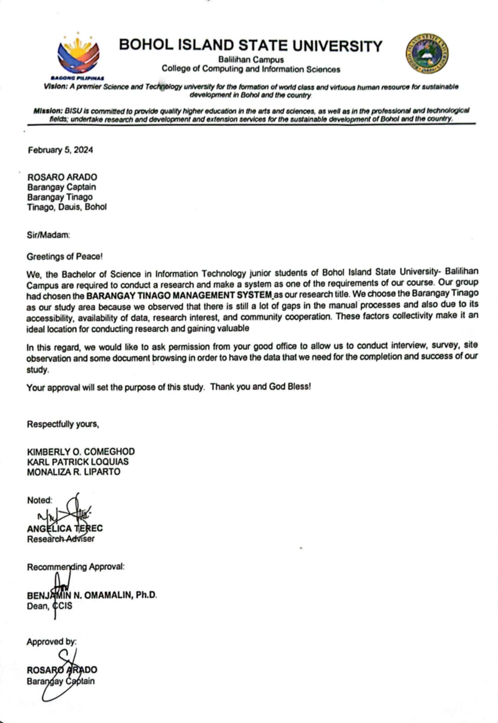
LETTER OF INTENT
APPENDIX B
MODELING TOOLS
DECISION SYMBOL

● A decision or branching point. Lines representing different decisions emerge from different points of the diamond
DATA SYMBOL

● Indicates where data is stored.

● An opened-end rectangle used to present storage

● A symbol used to represent input or output choices in a process.
PROCESS SYMBOL

● Symbol used for processing of data into useful information

● Describes a part of the system that transforms data inputs and outputs in the same way
TERMINAL SYMBOL

● Indicates the origin of data and its predetermined end

● Describes external entities referred to as a person or a group of departments with which the system communicates.

DATA FLOW SYMBOL

● Represent by an arrow which shows the direction or movement of the flow of data into the system

ON PAGE CONNECTOR SYMBOL

● Indicates that the flow continues where a matching symbol (containing the same letter inside the page) has been placed.

OUTPUT/DISPLAY SYMBOL

- Symbol used for displaying an output.
- It represents operations like displaying or printing information.

DATA INPUT SYMBOL

- Use for manual input.
- Use for form filling and submission.

OFF PAGE CONNECTOR SYMBOL

● Indicates that the flow continues where a matching symbol (containing the same letter outside the page) has been placed.

APPENDIX C
INTERVIEW GUIDE / QUESTIONS
- Can you describe how the current barangay management system operates, and what challenges do you encounter with it?
- What issues do you face in tracking resident information, including updates to personal and household details?
- How are payment collections managed, and are there any challenges with issuing receipts or tracking payments?
- What additional payment methods would be beneficial for residents to use?
- How are resident requests (e.g., clearances, certifications) submitted and processed?
- What specific features would you like to see in an integrated barangay management system?

APPENDIX D
User’s Guide
This guide provides detailed steps to set up and deploy the Barangay Tinago Management System, developed using the Laravel framework and MySQL database.
1. Prerequisites
Before proceeding, ensure you have the following:
- Source Code: The complete project files for the Barangay Tinago
Management System.
- Access to a Server: This can be a local server or a live hosting server (e.g., Apache or Nginx).
- Domain or IP Address: If deploying on a live server.
- Technical Knowledge: Familiarity with PHP, Laravel, and MySQL is recommended.
2. System Requirements
2.1 Hardware Requirements
- Processor: Intel Core i3 or higher
- RAM: 4GB or more
- Storage: 120GB HDD or larger
2.2 Software Requirements
- Operating System: Windows 7 or newer.
- Web Server: Apache (XAMPP, WAMP) or Nginx.
- PHP: Version 8.0 or higher.
- Composer: Dependency manager for PHP.
- Database: MySQL 5.7 or higher.
3. Setting Up the Environment
  - Server Setup
Local Deployment
- Install XAMPP or WAMP for Apache.
- Ensure PHP and MySQL modules are active.
Live Server Deployment
- Set up a VPS or shared hosting with support for PHP 8.0+ and MySQL.
- Install Apache or Nginx as the web server.
  - Installing Required Software
- Install Composer: Download and install Composer from https://getcomposer.org/
- Install Laravel (if not already included in the source code):
- Command: composer global require laravel/installer
4. Deploying the Application
4.1 Extract the Source Code
1. Download the source code (ZIP or from a version control system like Git)
2. Extract the project files into the server’s document root:
- For XAMPP: C:/xampp/htdocs/
- For Live Server: /var/www/html/
4.2 Install Dependencies
1. Open a terminal or command prompt.
2. Navigate to the project directory.
3. Run Composer to install required PHP dependencies: Command:
composer installs
4.3 Setup the Environment File
1. Duplicate the env.example file and rename it to .env
2. Update the .env file with the correct database credentials and other
configuration.
5. Configuring the Database
1. Create the Database
- Open your database management tool (e.g., phpMyAdmin).
- Create a new database with the name specified in the .env file (e.g., btms).
2. Run Migrations:
- In the terminal, execute the Laravel migrations to set up database
tables
3. Seed the Database (Optional)
- If seeders are available, populate the database with initial data.
6. Running the Application
- Local Server
1. Start the server (XAMPP or WAMP)
2. Run the Laravel development server
3. Open your browser and navigate to http://127.0.0.1:8000
- Live Server
1. Ensure the document root is set to the public directory of your Laravel project.
o For Apache, configure the VirtualHost in the httpd.conf file.
o For Nginx, update the server block in the configuration file.
2. Restart the server
3. Access the application using the domain or IP addresses
7. Troubleshooting
7.1 Common Issues
- Permission Denied Errors
Solution:
• Ensure proper file permissions for storage and bootstrap
directories.
- Missing Encryption Key
Solution:
• Generate a new application key.
- 500 Internal Server Error
Solution:
• Check the server error logs for details.
• Ensure the .env file has the correct configurations.
- Database Connection Error
Solution:
• Verify the database credentials in the .env file 107
• Ensure the database server is running
  - Support
For further assistance, contact the development team or consult the Laravel
documentation at https://laravel.com/docs.

Running and Navigation of the System
The user manual is designed to offer guidance to individuals using the system. This section demonstrates how to perform specific tasks, accompanied by visual illustrations.
User Login
Process Name: Login Page
Description: Allows the users to log in to the system, providing secure access to personalized features and functionalities.
Procedure:
- Enter username.
- Enter password.
- Click login button.
Barangay Official Module
Process Name: Adding Residents Information
Description: This page displays the form for adding a barangay resident.
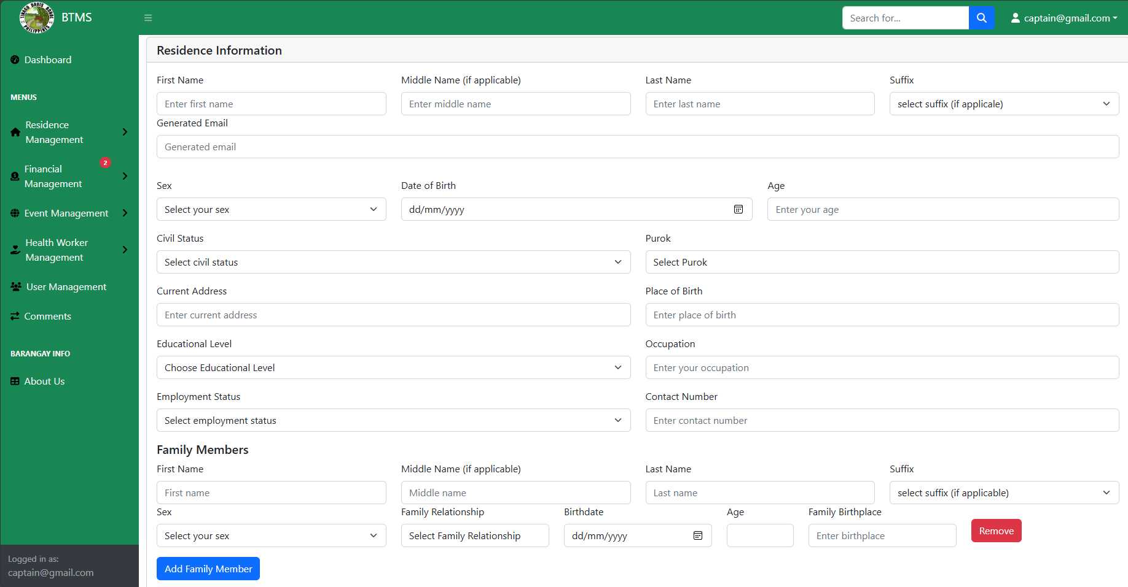
Procedure:
  - Click Residents Management.
  - Click Add Residents.
  - Enter Residents Information.
  - Click add.
Process Name: Adding Blotter records
Description: This page displays a form for adding blotter entries.

Procedure:
  - Click Residents Management.
  - Click Blotters List.
  - Click Add Blotters.
  - Input Blotter’s Information.
  - Click Save Blotter.
Process Name: Blotter Report
Description: Blotter Report Generation
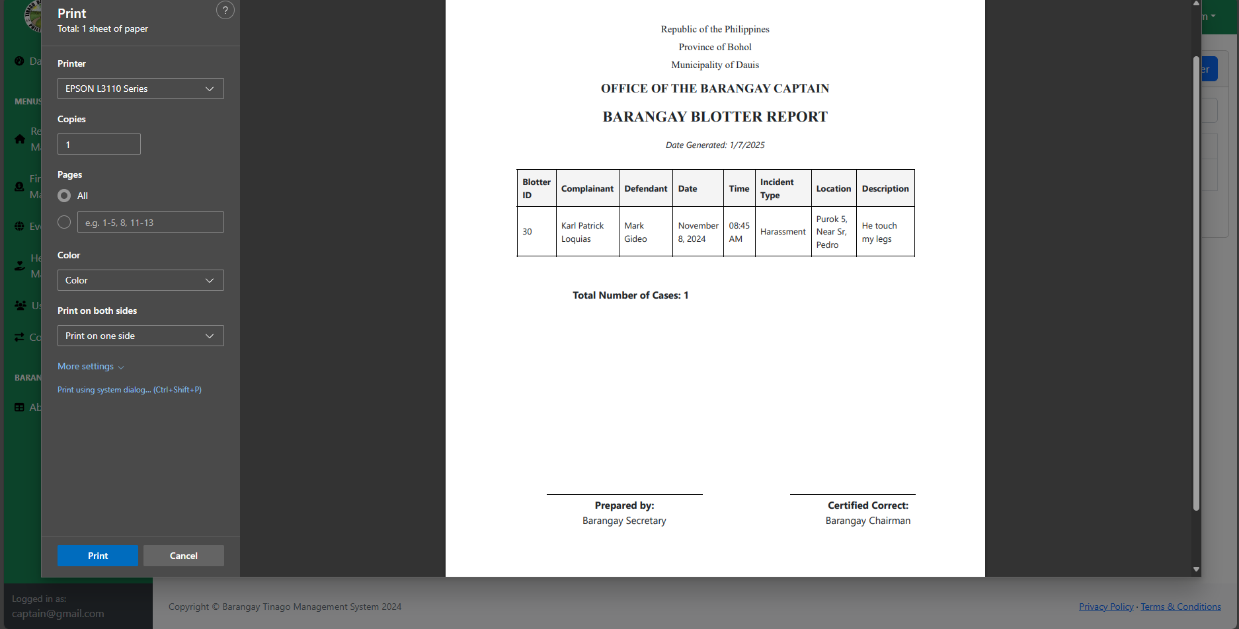
Procedure:
  - Click Residents Management.
  - Click Blotter’s List.
  - Click Generate Report.
Process Name: Residents Edit and Update
Description: Showing the residents details where you can edit and update, their information as needed, ensuring accurate and up-to-date records for better management and decision-making.
Procedure:
1. Click Residents Management
2. Click Residents List.
3. Click a Specific Resident.
4. Edit and Update a Specific Information.
5. Click Save.
Process Name: Residents Report
Description: Blotter Report Generation.
Procedure:
  - Click Residents Management.
  - Click Residents List.
  - Adjust the generate report accordingly using the filtering buttons.
  - Click Generate Report.
Process Name: Adding Budget Plan
Description: Adding a budget plan for that specific year. Adding a budget plan for that specific year ensures proper allocation of resources and financial stability. It helps in setting financial goals, tracking expenditures, and making informed decisions for sustainable growth.
Procedure:
  - Click Financial Management.
  - Click Budget Plan.
  - Click Add Planning.

Process Name: View Description
Description: Displays all transactions received by Barangay Officials. Adding a budget plan for that specific year ensures proper allocation of resources and financial stability. It helps in setting financial goals, tracking expenditures, and making informed decisions for sustainable growth.
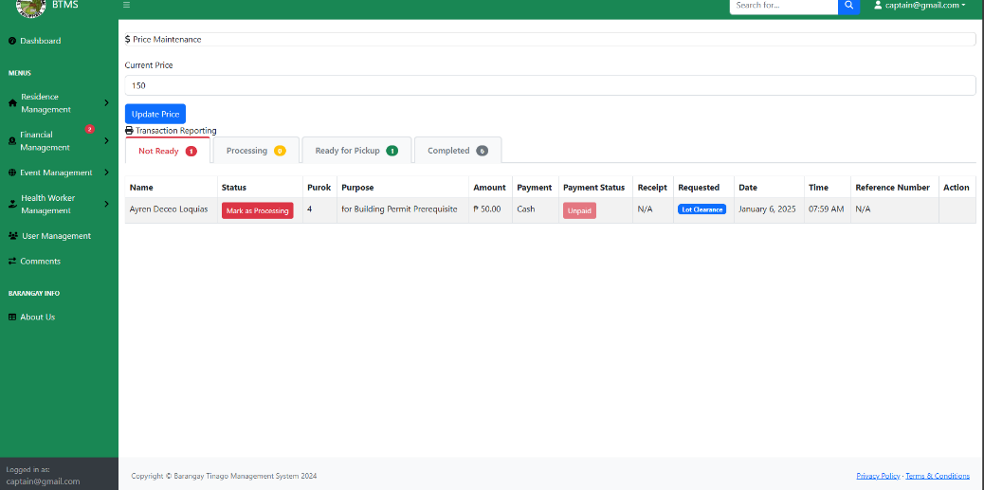

Procedure:
- Click Financial Management.
- Click Transaction.
- Click Mark as Processing to process the paper.
- Click Mark as Ready to verify that the document is ready.
- Click Ready for Pick Up to notify that the document is ready for pickup.

Process Name: Transaction Report
Description: Transaction report Generation.

Procedure:
- Click Financial Management.
- Click Transaction.
- Click the Completed Tab.
- Click the Generation Report.
Process Name: Adding Events
Description: Displaying a Form for adding an event.

Procedure:
- Click Event Management.
- Click Event.
- Click the Add Blotter.
- Input the event information.
- Click Save Event.
Process Name: Immunization Schedule
Description: Displaying the form for adding an Immunization Schedule.
Procedure:
- Click Health Worker Management.
- Click Schedule.
- Input immunization information.
- Click Save Immunization.

Processed Name: Users
Description: Display the list of active users, allowing you to reset their passwords or delete their accounts.
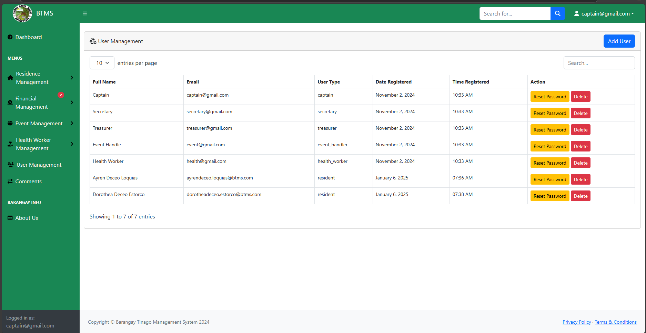
Procedure:
- Click User Management.
- To Reset a Password, Click Reset Password.
- To Delete a User, Click Delete.
Process Name: Add Comment
Description: Displays a field where the users can leave a comment
Procedure:
- Click Comments.
- Click the field for adding a comment.
- Click Send.
Barangay Residents Module:
Process Name: Document Request Form
Description: Residents can request specific documents, such as clearances and certificates.
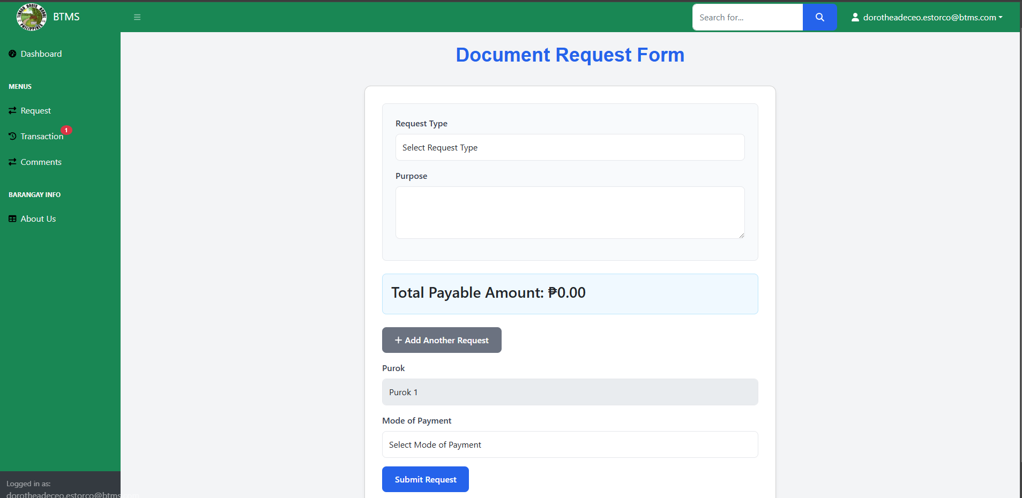
Procedure:
- Click Request.
- Fill in all the necessary fields for requesting the document.
- Click Submit Request.

Process Name: Transaction History
Description: Displays all transactions submitted by Barangay Residents.
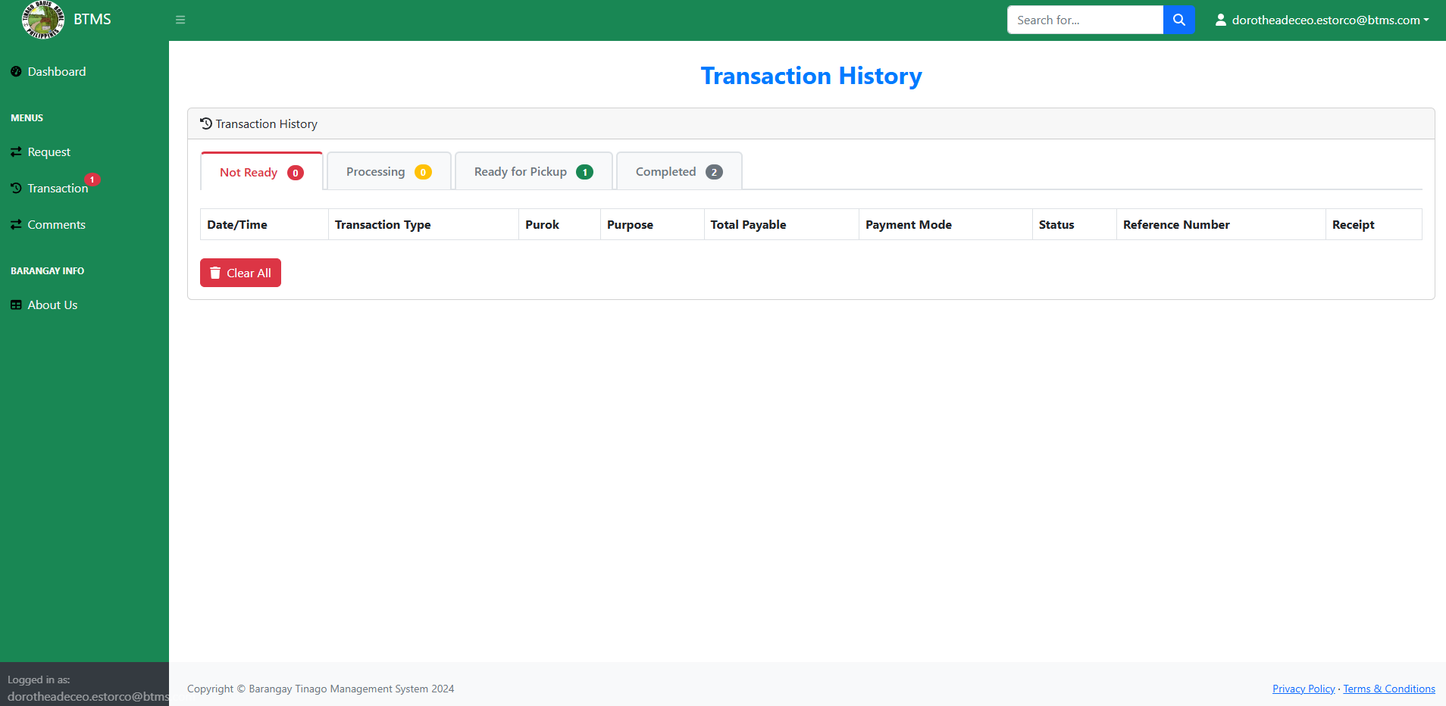
Procedure:
- Click Transaction.
- Select a tab depends on your

APPENDIX F

SOURCE CODE

dashboard.blade.php
@include('templates.header')

<style>
.announcement-title {
text-align: center;
margin: 30px 0;
font-size: 2.5rem;
font-weight: 800;
color: #0D7C66;
text-transform: uppercase;
letter-spacing: 2px;
text-shadow: 2px 2px 4px rgba(0, 0, 0, 0.1);
}

.event-list {
margin-top: 30px;
padding: 0 20px;
}

.event-item {
padding: 25px;
border-radius: 15px;
box-shadow: 0 8px 16px rgba(13, 124, 102, 0.1);
margin-bottom: 25px;
transition: all 0.3s ease;
border-left: 5px solid #0D7C66;
background: linear-gradient(to right, #ffffff, #f8f9fa);
margin-left: 40%;
width: 90%;
position: relative;
overflow: hidden;
}

.event-item:hover {
transform: translateY(-5px);
box-shadow: 0 12px 20px rgba(13, 124, 102, 0.15);

}

.event-date {
background: linear-gradient(135deg, #0D7C66, #0a5d4d);
color: white;
padding: 15px;
border-radius: 10px;
font-size: 1.1rem;
box-shadow: 0 4px 8px rgba(13, 124, 102, 0.2);
}

.event-date .number {
font-size: 1.5rem;
font-weight: bold;
margin-bottom: 5px;
text-shadow: 1px 1px 2px rgba(0, 0, 0, 0.2);
}

.event-title {
font-weight: bold;
font-size: 1.6rem;
color: #2c3e50;
margin-bottom: 15px;
padding-bottom: 10px;
border-bottom: 2px solid #eee;
}

.event-location {
color: #566573;
font-size: 1.1rem;
margin: 10px 0;
padding: 8px 0;
}

.badge {
padding: 8px 15px;
font-size: 0.9rem;
font-weight: 500;
letter-spacing: 0.5px;
border-radius: 20px;
margin-top: 10px;
}

.bg-danger {
background-color: #e74c3c !important;
}

.bg-info {
background-color: #3498db !important;
}

.immunization-details {
background-color: #f8f9fa;
padding: 12px 15px;
border-radius: 8px;
margin: 15px 0;
border: 1px solid #e9ecef;
}

.text-muted {
color: #626567 !important;
font-size: 1rem;
}

.mt-2 {
margin-top: 15px !important;
}

marquee {
font-size: 30px;
margin: 20px 0;
}
.scroll{
background: linear-gradient(45deg, #0D7C66, #0a5d4d);
}
.marquee-text {

color: white;
padding: 10px 20px;
border-radius: 25px;
box-shadow: 0 4px 6px rgba(13, 124, 102, 0.1);
display: inline-block;
font-weight: 600;
letter-spacing: 1px;
}

/* QR Code Styling */
.qr-container {
position: fixed;
left: 300px;
top: 55%;
transform: translateY(-50%);
z-index: 1000;
background-color: white;
padding: 10px;
border-radius: 12px;
box-shadow: 0 8px 16px rgba(0, 0, 0, 0.1);
transition: transform 0.3s ease;

}

.qr-container:hover {
transform: translateY(-52%) scale(1.05);
}

.qr-container img {
border-radius: 8px !important;
width: 500px !important; /* Change this value to whatever size you want */
height: 500px !important; /* Keep same as width */
object-fit: contain !important;
}

/* Additional Enhancements */
strong {
color: #0D7C66;
font-weight: 600;
}

p {
line-height: 1.6;
color: #444;
}
/* Update QR container style to include padding for text */
.qr-container {
position: fixed;
left: 300px;
top: 65%;
transform: translateY(-50%);
z-index: 1000;
background-color: white;
padding: 15px;
border-radius: 12px;
box-shadow: 0 8px 16px rgba(0, 0, 0, 0.1);
transition: transform 0.3s ease;
text-align: center;
}

.qr-container:hover {
transform: translateY(-52%) scale(1.05);
}

/* Style for the payment text inside QR container */
.qr-payment-text {
background: linear-gradient(45deg, #0D7C66, #0a5d4d);
color: white;
padding: 8px 12px;
border-radius: 6px;
font-weight: bold;
font-size: 0.85rem;
margin-bottom: 10px;
display: block;
animation: pulse 2s infinite;
}

@keyframes pulse {
0% {
transform: scale(1);
}
50% {
transform: scale(1.02);
}
100% {
transform: scale(1);
}
}

</style>

<div id="layoutSidenav_content">
<main>
<div class="container-fluid px-4">
@if(Auth::user()->user_type == "resident")
@php
$prenatals = App\Models\Prenatal::select('*', 'created_at as sort_date')->get()->toArray();
$immunizes = App\Models\Immunize::select('*', 'created_at as sort_date')->get()->toArray();
$events = App\Models\Event::select('*', 'created_at as sort_date')->get()->toArray();

$allRecordsArray = array_merge($prenatals, $immunizes, $events);
usort($allRecordsArray, function($a, $b) {
return strtotime($b['created_at']) - strtotime($a['created_at']);
});
@endphp

<div class="announcement-title">📢 Announcements</div>

<div class="qr-container">
<div class="qr-payment-text">
PLEASE SCAN THE CODE FOR PAYMENT 💳
</div>
@if(file_exists(public_path('assets/img/gcash.jpg')))
<img src="{{ asset('assets/img/gcash.jpg') }}" alt="QR Code">
@else
<div class="qr-placeholder">
<span>QR</span>
</div>
@endif
</div>
<div class= "scroll">
<marquee behavior="scroll" direction="left" scrollamount="15">
<span class="marquee-text">🏢 BARANGAY TINAGO MANAGEMENT SYSTEM 🏢</span>
</marquee>
</div>
<div class="event-list">
@foreach($allRecordsArray as $key => $record)
<div class="row event-item">
<div class="col-md-4">
<div class="event-date">
<div class="number">{{ $key + 1 }}</div>
<div>
@if(isset($record['activity']))
When: {{ \Carbon\Carbon::parse($record['created_at'])->format('M. d, Y') }}
@elseif(isset($record['vaccine']))
<div>When: {{ \Carbon\Carbon::parse($record['date'])->format('M. d, Y') }}</div>
<div>@ {{ \Carbon\Carbon::parse($record['time'])->format('h:i A') }}</div>
@else
<div>When: {{ \Carbon\Carbon::parse($record['event_date'])->format('M. d, Y') }}</div>
<div>@ {{ \Carbon\Carbon::parse($record['event_time'])->format('h:i A') }}</div>
@endif
</div>
<div>
@if(isset($record['activity']))
<span class="badge bg-danger">Pre-natal</span>
@elseif(isset($record['vaccine']))
<span class="badge bg-info">Immunization Announcement</span>
@else
<span class="badge bg-success">Event Announement</span>
@endif
</div>
</div>
</div>
<div class="col-md-8">
<div class="event-title">
@if(isset($record['activity']))
<strong>Activity:</strong> {{ $record['activity'] }}
@elseif(isset($record['vaccine']))
<strong>Vaccine:</strong> {{ $record['vaccine'] }}
<div class="immunization-details">
<strong>Required Age:</strong> {{ $record['age'] }} years old<br>
<strong>Dosage:</strong> {{ $record['dosage'] }}
</div>
@else
<strong>Event:</strong> {{ $record['event_type'] }}
@endif
</div>
<div class="event-location">
@if(isset($record['activity']))
<strong>Venue:</strong> {{ $record['venue'] }}
@elseif(isset($record['vaccine']))
<strong>Venue:</strong> {{ $record['venue'] }}
@else
<strong>Venue:</strong> {{ $record['event_venue'] }}
@endif
</div>
<p class="mt-2">
@if(isset($record['activity']))
{{ 'No description available.' }}
@elseif(isset($record['vaccine']))
<strong>Additional Notes:</strong> {{ $record['notes'] ?: 'No additional notes available.' }}
@else
{{ 'No description available.' }}
@endif
</p>
</div>
</div>
@endforeach

</div>
</main>
</div>

@else

@php
// Fetch the total counts directly in the view
$totalResidents = \App\Models\FamilyMember::count();
$totalHouseholds = \App\Models\Residence::count();

// Fetch the total population for Resident and the family members
$totalPopulation = $totalHouseholds + $totalResidents;

$totalBlotters = \App\Models\Blooter::count();
$totalUsers = \App\Models\User::count();

@endphp

<h1 class="mt-4">Dashboard</h1>
<ol class="breadcrumb mb-4">
<li class="breadcrumb-item active">Dashboard</li>
</ol>
<div class="row">
<div class="col-xl-3 col-md-6">
<div class="card flame bg-primary text-white mb-4">
<div class="card-body">
<h5>Total Household</h5>
<h2>{{ $totalHouseholds }}</h2> <!-- Display total residents -->
</div>
</div>
</div>
<div class="col-xl-3 col-md-6">
<div class="card flame bg-warning text-white mb-4">
<div class="card-body">
<h5>Total Residence</h5>
<h2>{{ $totalPopulation }}</h2> <!-- Display total households -->
</div>
</div>
</div>
<div class="col-xl-3 col-md-6">
<div class="card flame bg-danger text-white mb-4">
<div class="card-body">
<h5>Total Blotters</h5>
<h2>{{ $totalBlotters }}</h2> <!-- Display total blotters -->
</div>
</div>
</div>
<div class="col-xl-3 col-md-6">
<div class="card flame bg-success text-white mb-4">
<div class="card-body">
<h5>Total Users</h5>
<h2>{{ $totalUsers }}</h2> <!-- Display total users -->
</div>
</div>
</div>
</div>
<div class="row">
<div class="col-xl-12">
<div class="card mb-4">
<div class="card-header">
<i class="fas fa-chart-area me-1"></i>
Location Of Barangay Hall Tinago
</div>
<div class="card-body">
<iframe
src="https://www.google.com/maps/embed?pb=!1m18!1m12!1m3!1d3922.1683786811097!2d123.82422836451473!3d9.60863975364867!2m3!1f0!2f0!3f0!3m2!1i1024!2i768!4f13.1!3m3!1m2!1s0x33aa529c78aa6b05%3A0xd71b6305b6142930!2sTinago%20Barangay%20Hall!5e0!3m2!1sen!2sph!4v1697375840675!5m2!1sen!2sph"
width="1610"
height="450"
style="border:0;"
allowfullscreen=""
loading="lazy"
referrerpolicy="no-referrer-when-downgrade">
</iframe>
</div>
</div>
</div>
<!-- <div class="col-xl-6">
<div class="card mb-4">
<div class="card-header">
<i class="fas fa-chart-bar me-1"></i>
Bar Chart Example
</div>
<div class="card-body"><canvas id="myBarChart" width="100%" height="40"></canvas></div>
</div>
</div> -->
</div>

@endif
</div>
</main>
@include('templates.footer')

@include('templates.header')

<div id="layoutSidenav_content">
<main>
<div class="container-fluid mt-4">
<!-- Bootstrap Card -->
<div class="card">
<div class="card-header">
<h5 class="mb-0">Residence Information</h5>
</div>
<div class="card-body">
<form method="POST" action="{{ route('residence.store') }}">
@csrf
<div class="row mb-3">
<div class="col-md-3">
<label for="firstName" class="form-label">First Name</label>
<input type="text" name="first_name" class="form-control" id="firstName" placeholder="Enter first name" required>
</div>
<div class="col-md-3">
<label for="middleName" class="form-label">Middle Name (if applicable) </label>
<input type="text" name="middle_name" class="form-control" id="middleName" placeholder="Enter middle name">
</div>
<div class="col-md-3">
<label for="lastName" class="form-label">Last Name</label>
<input type="text" name="last_name" class="form-control" id="lastName" placeholder="Enter last name" required>
</div>
<div class="col-md-3">
<label for="suffix" class="form-label">Suffix</label>
<select name="suffix" class="form-select" id="suffix">
<option disabled selected value="">select suffix (if applicale) </option>
<option value="N/A">N/A</option>
<option value="Jr.">Jr.</option>
<option value="Sr.">Sr.</option>
<option value="II">II (The Second)</option>
<option value="III">III (The Third)</option>
</select>
</div>
<div class="mb-3">
<label for="generatedEmail" class="form-label">Generated Email</label>
<input type="text" name="email" class="form-control" id="generatedEmail" placeholder="Generated email" readonly>
</div>
</div>

<div class="row mb-3">
<div class="col-md-3">
<label for="sex" class="form-label">Sex</label>
<select name="sex" class="form-select" id="sex" required>
<option disabled selected value=""> Select your sex</option>
<option value="male">Male</option>
<option value="female">Female</option>
<option value="other">Prefer not to say</option>
</select>
</div>
<div class="col">
<label for="dob" class="form-label">Date of Birth</label>
<input type="date" name="date_of_birth" class="form-control" id="dob" required>
</div>
<div class="col">
<label for="age" class="form-label">Age</label>
<input type="number" name="age" class="form-control" id="age" placeholder="Enter your age" min="0" readonly required>
</div>

</div>

<div class="row mb-3">
<div class="col">
<label for="civilStatus" class="form-label">Civil Status</label>
<select name="civil_status" class="form-select" id="civilStatus" required>
<option disabled selected value="">Select civil status</option>
<option value="single">Single</option>
<option value="married">Married</option>
<option value="divorced">Divorced</option>
<option value="widowed">Widowed</option>
</select>
</div>
<div class="col">
<label for="purok" class="form-label">Purok</label>
<select name="purok" class="form-control" id="purok" placeholder="Enter Purok" required>
<option disabled selected value="">Select Purok</option>
<option value="1">1</option>
<option value="2">2</option>
<option value="3">3</option>
<option value="4">4</option>
<option value="5">5</option>
<option value="6">6</option>
<option value="7">7</option>
</select>
</div>
</div>

<div class="row mb-3">
<div class="col">
<label for="currentAddress" class="form-label">Current Address</label>
<input type="text" name="address" class="form-control" id="currentAddress" placeholder="Enter current address" required>
</div>
<div class="col">
<label for="placeOfBirth" class="form-label">Place of Birth</label>
<input type="text" name="place_of_birth" class="form-control" id="placeOfBirth" placeholder="Enter place of birth">
</div>
</div>

<div class="row mb-3">
<div class="col">
<label for="educationalLevel" class="form-label">Educational Level</label>
<select name="educational_level" class="form-select" id="educationalLevel" required>
<option disabled selected value="">Choose Educational Level</option>
<option value="elementary_level">Elementary Level</option>
<option value="elementary_graduate">Elementary Graduate</option>
<option value="highschool_level">Highschool Levle</option>
<option value="highschool_graduate">Highschool Graduate</option>
<option value="college_level">College Level</option>
<option value="college_graduate">College Gradaute</option>
<option value="post_grad">Post Graduate</option>
<option value="n/a">N/A</option>
</select>
</div>
<div class="col">
<label for="occupation" class="form-label">Occupation</label>
<input type="text" name="occupation" class="form-control" id="occupation" placeholder="Enter your occupation" required>
</div>
</div>

<div class="row mb-3">
<div class="col">
<label for="employmentStatus" class="form-label">Employment Status</label>
<select name="employment_status" class="form-select" id="employmentStatus" required>
<option disabled selected value="">Select employment status</option>
<option value="employed">Employed</option>
<option value="unemployed">Unemployed</option>
<option value="self-employed">Self-employed</option>
<option value="part_time">Part Time</option>
<option value="full_time">Full Time</option>
</select>
</div>
<div class="col">
<label for="contactNumber" class="form-label">Contact Number</label>
<input type="tel" name="contact_number" class="form-control" id="contactNumber"
placeholder="Enter contact number" required
pattern="^\d{11}$"
title="Contact number must be exactly 11 digits"
maxlength="11">
</div>
</div>

<!-- Family Members Section -->
<div id="familyMembers">
<h5>Family Members</h5>
<div class="row mb-3">
<div class="col-md-3">
<label for="familyFirstName1" class="form-label">First Name</label>
<input type="text" name="family_first_names[]" class="form-control" id="familyFirstName1" placeholder="First name" required>
</div>
<div class="col-md-3">
<label for="familyMiddleName1" class="form-label">Middle Name (if applicable)</label>
<input type="text" name="family_middle_names[]" class="form-control"

RESEACHER’S BIODATA

PERSONAL DATA
Name : Kimberly O. Comeghod
Nick Name : Kim
Date of Birth : March 26, 2003
Place of Birth : Cebu City
Home Address : Boctol, Balilihan, Bohol
Email Address : kimkimcomeghod@gmail.com
Civil Status : Single
Citizenship : Filipino
Father’s Name : Richard A. Comeghod
Mother’s Name : Carmelita O. Comeghod

EDUCATIONAL BACKGROUND

Elementary : Boctol Elementary School
Secondary : Cong. Pablo Malasarte National High School
Tertiary : Bohol Island State University – Balilihan Campus
Motto : “Trust The Timing of Your Life.”

RESEACHER’S BIODATA

PERSONAL DATA
Name : Karl Patrick D. Loquias
Nick Name : Karl
Date of Birth : August 25, 2003
Place of Birth : Palupadan, Negros Occidental
Home Address : Tinago, Dauis, Bohol
Email Address : loquiaskarl18@gmail.com
Civil Status : Single
Citizenship : Filipino
Father’s Name : Simfronyo Loquias
Mother’s Name : Ayren Loquias

EDUCATIONAL BACKGROUND
Elementary : Tinago Dauis Elementary School
Secondary : Tabalong Dauis National High School
Tertiary : Bohol Island State University – Balilihan Campus
Motto : “Do your best and God will do the rest.”

RESEACHER’S BIODATA

PERSONAL DATA
Name : Monaliza R. Liparto
Nick Name : Mona
Date of Birth : January 26, 2003
Place of Birth : Matabao, Tubigon, Bohol
Home Address : Boyog Proper, Balilihan, Bohol
Email Address : lipartomonaliza@gmail.com
Civil Status : Single
Citizenship : Filipino
Father’s Name : Ireneo C. Liparto
Mother’s Name : Cecelia R. Liparto

EDUCATIONAL BACKGROUND
Elementary : Hanopol Elementary School – Hanopol Weste Balilihan Bohol
Secondary : Hanopol National High School – Sto Nino, Balilihan Bohol
Tertiary : Bohol Island State University – Balilihan Campus
Motto : “Empty your cup, in order to fill it again”

